# MediFuzz: Implementing Type 1 Fuzzy Logic for Accurate Health Diagnostics

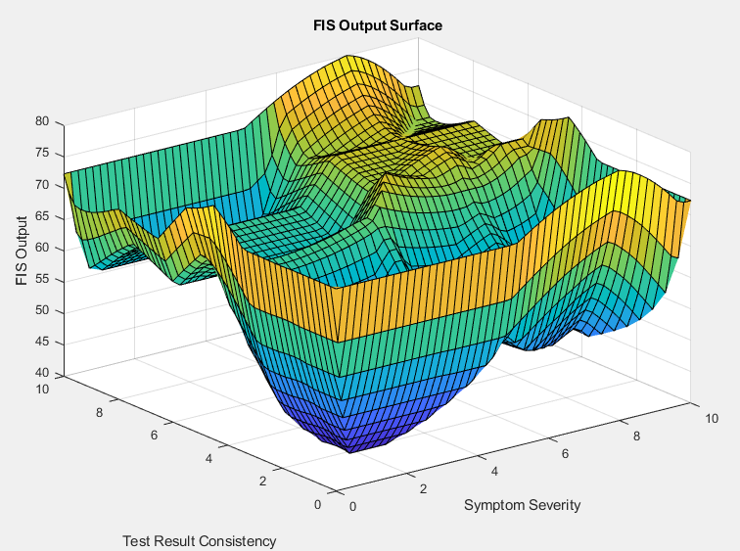

Figure.1. – Final Best Run Surface Plot (Centroid)

Word Count: 6455

Report Appendix: Pages 31-49

Code Appendix: Pages 50-65

Report: Pages 6-29

References: Page 30

Contents

MediFuzz: Implementing Type 1 Fuzzy Logic for Accurate Health Diagnostics 1

Table of Figures 3

1. - Introduction: 6

1.1 - Introduction to Fuzzy Logic: 6

1.2 - Review of Literature: 6

1.3 - Historical Context and Evolution: 7

1.4 - Advanced Fuzzy Logic in Healthcare Review 7

2. - FIS System Proposal: Utilising Mamdani Type 1 for Medical Diagnosis 7

2.1 - Overview 7

2.2 - Rationale for Using Mamdani Type 1 FIS 7

2.3 - Inputs and Output 8

2.3.1 - Linguistic Variable Justification 8

2.4 - Use of Pseudo Data 8

2.4.1 - Data Creation & Considerations 8

2.4.2 - Preliminary Data Testing 9

2.4.3 - Data Quality Checks: 10

2.5 - Exploratory Research 10

2.5.1 - Exploratory Code Description 10

3. - Rulebase 12

3.1 - Choice of Operator 12

4. - Testing & Analysis 13

4.1 - Run One Analysis 13

4.2 - Run Two Analysis – Varying Changes 15

4.2.1 - Rulebase Changes Description & Analysis 17

4.2.2 - Changes to Membership Functions Overlap & Analysis 17

4.3 - Run Three Analysis – Input Granularity Refinement With Gaussian 19

4.4 - Run Four Analysis – Refined Membership Functions, Rules & Data 21

4.4.1 - Run Four A – Gaussian with New Rules 22

4.4.2 - Run Four B – Trimf with New Rules 23

4.4.3 - Run Four C – Trapmf with New Rules 24

4.5 - Run Five – Back To Basics 24

4.5.1 - Introduction of New Rules Based on Two Scenarios: 25

4.5.2 - Run Five A 25

4.5.3 - Run Five B 26

4.5.4 - Run Five C 26

4.5.5 – Excel Data Analysis 27

4.6 - Run Six – Defuzz Deep Dive 28

5. – Conclusions 28

5.1 - Future Research 29

6 - References 30

7 - Appendix 31

7.1 - Plain English Rulebase – Runs One, Two, Three, Five & Six 31

7.2 - Plain English Rulebase –Run Four 33

7.3 - Outlier Scenarios Rules 35

7.3.1 - Scenario 1: Test Result Consistency 35

7.3.2 - Scenario 2: Symptom Severity and Patient History Relevance 35

7.4 - Testing Appendices 36

7.4.1 - Run One 36

7.4.2 – Run Two 37

7.4.3 – Run Three 39

7.4.4 – Run Four 40

7.4.5 – Run Five 46

7.4.6 – Run Six 49

8 - Code Appendix 52

8.1 - Exploratory Code 52

8.2 - Data Generation Code 52

8.3 - Preliminary Data Generation & Testing Code 53

8.4 - First Three Runs MatLab Code 55

8.5 - Gaussian Membership Functions Code 59

8.6 - Different Code Variations 63

8.6.1 - Gaussian Membership Functions 63

8.6.2 - Trimf Membership Functions 64

8.6.3 - Trapmf Membership functions 64

# Table of Figures

Figure.1. – Final Best Run Surface Plot (Centroid) 1

Table.1. – Inputs, Output, & Linguistic Variables 8

Figure.2. – Preliminary Data Test Results 10

Figure.3. – Membership Functions Modelled in Google Colab using Python 11

Figure.4. – Run One: Centroid, MoM, LoM, SoM, Bisector Comparison 13

Figure.5. – Run One: PCA Scatter Plot and Bar chart of Variance 13

Figure.6. – Run One: Rule Viewer 14

Figure.7. – Run One: Sensitivity Analysis for Symptom Severity & Output Surface Plot 14

Figure.8. – Run Two: Input Membership Functions & Surface Plot 15

Figure.9. – Run Two: Centroid, MoM, LoM, SoM, Bisector Comparison 15

Figure.10. – Run Two: Sensitivity Analysis 16

Figure.11. – Run Two: Rule Viewer 16

Figure.12. – Run Two: First Test Prior to system tweaking 17

Figure.13. – Run Two: Surf Plot Post-MF Changes 18

Figure.14. – Run Three: Guassian Membership Functions 18

Figure.15. – Run Three: Defuzzification Methods Comparison 19

Figure.16. – Run Three: Rule Viewer 19

Figure.17. – Run Three: Sensitivity Analysis & Surface Plot 20

Figure.18. – Run Four: Initial Input Membership Functions 21

Figure.19. – Run Four: Excel Data Analysis Line Graph 21

Figure.20. – Run Four: Excel Data Analysis Scatter Plot 21

Figure.21. – Gaussian Membership Functions 22

Figure.22. – Run Four A L-R: Surf plot with theoretically optimal overlap & Surf plot of increased overlap 23

Figure.23. – Run Four B L-R: Surf plot of increased overlap & surf plot with theoretically optimal overlap 23

Figure.24. – Run Four A L-R: Surf plot with theoretically optimal overlap & Surf plot of increased overlap 24

Figure.25. – Run Five A: Surfplot 25

Figure.26. – Run Five B: Surface Plot 26

Figure.27. – Run Five C L-R: Bisector Surface Plot & Centroid Surface Plot 27

Figure.28. – Run Five: Excel Data Analysis Line Graph 27

Figure.29. – Run Five: Excel Data Analysis Scatter Plot 27

Figure.30. – Final Best Output Post System Refinements Centroid; System 3) 28

Figure.31. – Run One: Excel Data Analysis 35

Figure.32. – Run One: Sensitivity Analysis 36

Figure.33. – Run One: Rule Viewer 36

Figure.34. – Run One, L-R: Ruleviewer Surface, Sensitivity Analysis Line Graph, Visually Improved Surface 36

Figure.35. – Run Two: Rule Viewer 37

Figure.36. – Run Two, L-R: Ruleviewer Surface, Sensitivity Analysis Line Graph, Visually Improved Surface 37

Figure.37. – Run Two: Excel Data Analysis 37

Figure.38. – Run Two: Input Membership Functions 38

Figure.39. – Run Two: Rule Viewer 38

Figure.40. – Run Two, L-R: Ruleviewer Surface, Sensitivity Analysis Line Graph, Visually Improved Surface 38

Figure.41. – Run Three: Excel Data Analysis 39

Figure.42. – Run Three: Gassian Membership Functions 39

Figure.43. – Run Three: Rule Viewer 39

Figure.44. – Run Three, L-R: Sensitivity Analysis & Surface Plot 40

Figure.46. – Run Four: Symptom Severity Input Membership Function Description 40

Figure.47. – Run Four: Test Result Consistency Input Membership Function Description 40

Figure.48. – Run Four (Baseline Run): Input Membership Functions (Trapmf & Trimf) 41

Figure.49. – Run Four (Baseline Run): Rule Viewer 41

Figure.50. – Run Four (Baseline Run), L-R: Sensitivity Analysis & Surface Plot 41

Figure.51. – Fourth Run (2 of 4 Runs), L-R: Input MFs & Output MF (Gaussian) 42

Figure.52. – Fourth Run (2 of 4 Runs): Rule Viewer (In two parts due to increase in rules) 42

Figure.53. – Fourth Run (2 of 4 Runs), L-R: Surface Plots of the Best Performing Defuzzification Methods 42

Figure.54. – Fourth Run (3 of 4 Runs): Input MFs (Triangular) 43

Figure.55. – Fourth Run (3 of 4 Runs): Rule Viewer (in two parts because of increase in rules) 43

Figure.56. – Fourth Run (3 of 4 Runs), L-R: Ruleviewer Surface & Visually Improved Surface Plots 44

Figure.57. – Fourth Run (3 of 4 Runs): The Best Defuzzification Methods Surface Plots 44

Figure.58. – Fourth Run (4 of 4 Runs): Input MFs (Trapezoid) 44

Figure.59. – Fourth Run (4 of 4 Runs): Rule Viewer 45

Figure.60. – Fourth Run (4 of 4 Runs), L-R: Best Surface Plots of Defuzzification Methods 45

Figure.61. – Fifth Run (1 of 3 Runs): Input MFs 46

Figure.62. – Fifth Run (1 of 3 Runs): Rule Viewer 46

Figure.63. – Fifth Run (1 of 3 Runs), L-R & T-B: Rule Viewer Surface, Defuzzification Methods Surface Plot 47

Figure.64. – Fifth Run (2 of 3 Runs): Rule Viewer 47

Figure.65. – Fifth Run (2 of 3 Runs), L-R: Rule Viewer Surface, Defuzzification Methods Worst & Best Surface Plot 48

Figure.66. – Fifth Run (3 of 3 Runs): Input MFs 48

Figure.67. – Fifth Run (3 of 3 Runs): Ruleviewer 48

Figure.68. – Fifth Run (3 of 3 Runs): Ruleviewer Surface & Visually Improved Surface 49

Figure.69. – Fifth Run (3 of 3 Runs): Defuzzification Methods Surface Plots 49

Figure.70. – Sixth Run: Best Performing Centroid Defuzzification Method Surface Plots 49

Figure.71. – Sixth Run: Best Performing Bisector Defuzzification Method Surface Plots 50

Figure.72. – Sixth Run: Best Performing MoM Defuzzification Method Surface Plots 50

Figure.73. – Sixth Run: Best Performing LoM Defuzzification Method Surface Plots 51

Figure.74. – Sixth Run: Best Performing SoM Defuzzification Method Surface Plots 51

MediFuzz Project Notes (Zip File Navigation):

File – P2629898 (Main Report)

Code Directory – Contains all code to do with this project (Including pre-analysis Jupyter Notebook which can be run using Google Colab)

Media Directory – Contains all images for figures in this project

Spreadsheets Directory – Contains all base spreadsheets for each run which include individual defuzz additions in the respective columns

OldProjects – Contains old ideas should you wish to peruse these (Not compulsory)

# 1. - Introduction:

In the rapidly evolving field of healthcare technology, the adoption of advanced computational methods has proven instrumental in enhancing diagnostic precision and supporting clinical decisions. This project explores the use of fuzzy logic, a computational technique that emulates human reasoning in conditions of uncertainty, to develop a preliminary model of a healthcare decision support system for disease diagnosis. The aim is to assess the feasibility of this approach in improving diagnostic outcomes.

## 1.1 - Introduction to Fuzzy Logic:

Fuzzy logic was conceptualised by Lotfi A. Zadeh in the mid-1960s as part of his research on systems theory at the University of California, Berkeley. It challenges the traditional dichotomy of conventional logic by introducing degrees of truth instead of the usual "true or false" (1 or 0) binary. Fuzzy logic systems use 'fuzzy sets' or categories that are not mutually exclusive, allowing for intermediate values to express reasoning that aligns more closely with human-like thinking. This makes it particularly suitable for areas like healthcare, where medical decisions often involve ambiguity and gradation of truths. (Zadeh, 1965).

## 1.2 - Review of Literature:

The relevance of fuzzy logic in medical diagnostics has been explored in various studies and articles. Notably, the International Journal of Fuzzy Systems has published several papers discussing the implementation of fuzzy logic in clinical decision support tools, highlighting its capability to handle imprecision inherent in medical diagnosis (International Journal of Fuzzy Systems, n.d.). Furthermore, Fuzzy Sets and Systems often features articles that delve into the theoretical aspects of fuzzy logic applications in medicine, offering insights into how fuzzy methodologies can refine decision-making processes in complex systems like healthcare.

Fuzzy logic is widely utilised in healthcare decision-support systems, particularly in regions with low doctor-to-patient ratios, where it enhances diagnostic decisions (Gupta, Singh, and Singla, 2022). These systems, based on expert knowledge encoded into IF-THEN rules, accurately replicate medical diagnostics through a process involving fuzzification, inference, and defuzzification. The integration with neural networks, forming adaptive neuro-fuzzy models, further optimises these systems, showing superior performance across various diseases, including chronic and acute conditions, which could be a method implemented in future projects. The review highlights the potential for future advancements in multi-layered fuzzy systems and underscores existing challenges like the manual creation of rules and membership functions (Gupta, Singh, and Singla, 2022).

The paper by Ahmadi et al. (2018) systematically reviews the application of fuzzy logic methods in disease diagnosis, highlighting the role of these techniques in reducing the ambiguity and uncertainty inherent in clinical decision-making. Recognising the complexity and uncertain nature of medical practice, the study utilises the Preferred Reporting Items for Systematic Reviews and Meta-Analyses (PRISMA) method across eight scientific databases to conduct a thorough meta-analysis. By evaluating numerous studies based on various criteria such as applied fuzzy methods, research objectives, and medical disciplines, the review demonstrates the effectiveness of fuzzy logic in simplifying the diagnostic process. It also identifies specific diseases that have garnered more focus and pinpoints diagnostic aspects within medical disciplines that require further research. This comprehensive approach not only confirms the beneficial impact of fuzzy methods on disease diagnosis but also sets a foundation for future investigations in this critical area of medical research (Ahmadi et al., 2018).

## 1.3 - Historical Context and Evolution:

The concept of decision support systems in medicine predates the formal introduction of fuzzy logic. The integration of computational and statistical tools to assist in clinical decision-making has been part of medical informatics since the 1970s. The work of Mamdani and Assilian on the application of fuzzy logic controllers in steam engines in 1974 provided a foundational model for applying fuzzy logic to control systems, which was later adapted to medical diagnostic systems, (Mamdani and Assilian, 1999). The Journal of Biomedical Informatics and Artificial Intelligence in Medicine provide comprehensive retrospectives that chart the evolution of decision support mechanisms, from simple expert systems to complex architectures incorporating fuzzy logic, thereby improving the handling of nuanced medical data. (Journal of Biomedical Informatics, n.d.).

## 1.4 - Advanced Fuzzy Logic in Healthcare Review

The use of fuzzy logic for diagnosing chronic diseases, as shown in recent studies (Smith et al., 2023), offers a promising framework to manage the inherent uncertainty in patient data, leading to more accurate assessments. Furthermore, the integration of fuzzy logic with neural networks, as illustrated in the development of Adaptive Neuro-Fuzzy Inference Systems (ANFIS) (Jones & Wu, 2023), opens new pathways for intelligent disease prediction that adapt to dynamic data patterns. Additionally, hybrid fuzzy expert systems specifically tailored for early diagnosis of cardiac diseases have demonstrated that combining fuzzy logic with expert systems can enhance precision in diagnostic recommendations (Patel & Gomez, 2023). These advances underline the critical role fuzzy logic plays in medical diagnostics, paving the way for future research to introduce innovative AI-based solutions that harness the power of fuzzy inference to handle the complexities of medical data. Exploring hybrid models that blend fuzzy logic with deep learning or other AI techniques could further revolutionise diagnostic systems, enabling healthcare professionals to diagnose with unparalleled accuracy and provide personalised treatment paths for patients.

# 2. - FIS System Proposal: Utilising Mamdani Type 1 for Medical Diagnosis

## 2.1 - Overview

This proposal outlines the implementation of a Mamdani Type 1 Fuzzy Inference System (FIS) designed to enhance medical diagnostic processes. The Mamdani method, renowned for its simplicity and widespread application in control systems, offers a robust framework for handling the inherent uncertainties in medical data analysis.

## 2.2 - Rationale for Using Mamdani Type 1 FIS

The choice of a Mamdani Type 1 FIS is driven by its suitability for applications where human-like reasoning and qualitative expertise are desired. This system's ability to process linguistic variables effectively mirrors the way medical practitioners interpret vague and imprecise data to make diagnostic decisions. Furthermore, the Mamdani FIS, being less computationally intensive compared to other types like Sugeno, aligns well with the real-time processing needs of medical diagnostics without sacrificing accuracy.

## 2.3 - Inputs and Output

The system will consider three primary inputs, called Membership Functions (MF), each represented by linguistic variables that describe the patient's symptoms or test results. There will be experimentation with trapmf, trimf and gaussmf, (See appendix 7.5 for the formulas). The output will be the likelihood of a specific diagnosis, also expressed as a linguistic variable. Below is a table detailing these inputs and the proposed output:

|  |  |  |
| --- | --- | --- |
| Input / Output | Description | Linguistic Variables |
| Input 1 | Symptom Severity | Low, Moderate, High |
| Input 2 | Test Result Consistency | Inconsistent, Moderately Consistent, Consistent |
| Input 3 | Patient History Relevance | Irrelevant, Somewhat Relevant, Highly Relevant |
| Output | Likelihood of Disease Diagnosis | Unlikely, Possible, Probable, Highly Probable |

Table.1. – Inputs, Output, & Linguistic Variables

### 2.3.1 - Linguistic Variable Justification

The linguistic variables for each input are chosen based on typical clinical assessments that categorise the severity and relevance of symptoms and test results. This categorisation helps in simplifying complex medical data into manageable and interpretable formats. The output variable 'Likelihood of Disease Diagnosis' is designed to provide a straightforward, actionable output that aids medical professionals in decision-making.

## 2.4 - Use of Pseudo Data

Given the preliminary nature of this project, pseudo data, which simulates real patient data, will be employed to develop and test the system. This approach allows for the refinement of the FIS without ethical concerns and logistical complexities associated with real patient data. The pseudo data will be modelled to reflect realistic scenarios, based on typical distributions and variations found in actual medical data.

This FIS proposal utilises the Mamdani Type 1 model due to its alignment with qualitative decision-making in medicine, providing a framework that enhances diagnostic precision in the face of ambiguous clinical data. By translating complex medical terms and data into comprehensible linguistic terms, the FIS facilitates an intuitive diagnostic process that supports clinicians in delivering accurate health assessments.

### 2.4.1 - Data Creation & Considerations

This code in the appendix named ‘Data Generation Code’ for a more detailed code description and reasons for the decisions approached in the code. This is crafted to create a synthetic dataset of patient information, which serves as a stand-in for real patient data. Each step is taken with the intent of mimicking realistic patient data while maintaining reproducibility and ethical considerations. Two sets of data were created each with 150 and 1000 data points.

### 2.4.2 - Preliminary Data Testing

NB: Please see Appendix named ‘Preliminary Data Testing Code’ for the code related to this section. See also figure 2 for the results figures.

##### Descriptive Statistics:

* The descriptive statistics indicate central tendency and dispersion measures for each input variable.

##### Symptom Severity:

* The mean is approximately 5.12, with a standard deviation of around 2.02, suggesting moderate average severity with some variation.
* The median, or 50th percentile, is about 5.18, indicating that half of the pseudo patients have a symptom severity below this value.
* The minimum and maximum values are within the specified range of 0 to 10, and the interquartile range (IQR), from the 25th to the 75th percentile, suggests a moderate spread of data.

##### Test Result Consistency:

* The mean is close to 5.16, and a similar standard deviation implies consistent data variability as the severity of symptoms.
* The median value of 5.04 is almost the same as the mean, which can be a sign of a symmetrical distribution of data points.
* The values are also within the expected range.

##### Patient History Relevance:

* A lower mean of approximately 4.88 with a standard deviation of 1.98 indicates that, on average, the patient history is slightly less relevant compared to the other variables.
* The median of 4.85 is quite close to the mean, supporting the normal distribution assumption.
* The range and IQR show a reasonable spread without extreme outliers.

##### Distribution Fit:

* The Shapiro-Wilk test examines the normality of the data distributions.

##### Symptom Severity:

* A p-value of approximately 0.96 suggests the data do not significantly deviate from a normal distribution.

##### Test Result Consistency:

* A p-value close to 0.85 reinforces the presumption of normality.

##### Patient History Relevance:

* A p-value of around 0.74 further supports the hypothesis that the data is normally distributed.

Since all p-values are greater than the common alpha level of 0.05, there is no reason to reject the null hypothesis of normality, indicating that the assumption of normal distribution is reasonable for this data.

### 2.4.3 - Data Quality Checks:

The null values check indicates that there are no missing values in the dataset for any of the input variables, which is ideal for ensuring the FIS operates on a complete dataset without the need for imputation or data cleaning steps. The outlier detection has yielded a count of zero outliers for all input variables, which is an excellent result as it means there are no data points that fall significantly outside the range of what has been deemed normal for this pseudo dataset. This ensures that the FIS will not be unduly influenced by extreme values.

The output from these statistical tests provides confidence that the pseudo patient data generated for this project is well-structured and follows the assumed normal distribution. This validates the approach taken for creating the dataset and indicates that the data is ready for further use in developing and testing the FIS. It is important for the subsequent phases of the project that the system's configurations, especially the membership functions and rule base, accurately reflect this distribution and the characteristics of the data to ensure that the FIS models the decision-making process as closely as possible to a real-world clinical setting.

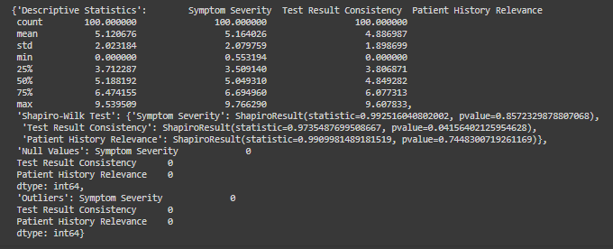

Figure.2. – Preliminary Data Test Results

## 2.5 - Exploratory Research

The code in the appendix named ‘Exploratory Code’, sets the foundation for MediFuzz. The significance of this initial system lies in its ability to simulate the nuanced decision-making process of medical professionals. Therefore, some pre-modelling using Python helped to ensure that this type of system is suitable.

### 2.5.1 - Exploratory Code Description

NB: See appendix named ‘Exploratory Code’ for the code used in this exploration stage.

Definition of Universe and Linguistic Variables: The universes of discourse for the inputs (Symptom Severity, Test Result Consistency, Patient History Relevance) and the output (Likelihood of Disease Diagnosis) have been defined with a range from 0 to 10. This range allows for a fine-grained analysis of the variables involved in the diagnostic process.

Membership Functions: The MFs for the input and output variables have been established using both automatic and custom definitions, which correspond to typical clinical evaluations. This is pivotal as it translates the often vague clinical terms into quantifiable measures that a fuzzy system can process.

Rule Definition: A set of rules has been constructed to reflect the expert knowledge in the form of conditional statements (IF-THEN rules). For example, one rule states that if the symptom severity is high, the test results are consistent, and the patient history is highly relevant, then the diagnosis likelihood is highly probable. These rules are the core of the FIS, encapsulating the medical logic and expertise that guide the diagnostic process.

Control System Creation and Simulation: The control system is created from the defined rules, allowing for the simulation of the diagnostic process. This step is important because it brings together all the individual components of the fuzzy logic system and enables the evaluation of the system’s decision-making capabilities.

Simulation and Output Computation: The simulation is executed with specific input values, and the system computes the output, which in this case is the likelihood of a particular diagnosis. This allows for testing and refinement of the system before it is used with real or pseudo data.

The output graph in figure 3 visualises the membership functions for the output variable 'Likelihood of Disease Diagnosis'. It shows the fuzzy regions for 'unlikely', 'possible', 'probable', and 'highly probable' diagnoses, which overlap to varying degrees. The shaded area represents the result of the fuzzy inference given the test data input values, indicating the degree to which each diagnosis category applies.

In moving forward with the project, this pre-analysis is pivotal as it provides a testable model that reflects clinical reasoning in an uncertain environment. Adjustments to MFs, rules, and the universe of discourse can be made based on the analysis of this model, ensuring that the system accurately mimics the complexity of medical diagnosis before implementation with real or pseudo data. This preparatory phase is instrumental in ensuring the reliability and validity of the FIS when applied in a practical setting.

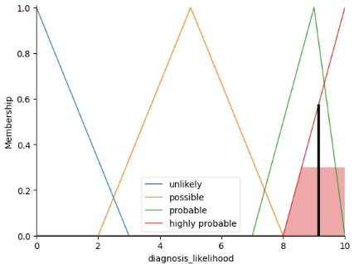

Figure.3. – Membership Functions Modelled in Google Colab using Python

# 3. - Rulebase

Please see Appendix 7.1 to 7.3 for the full set of rules including changes.

In the appendix named ‘Plain English Rulebase’, there comprises a set of 27 rules, each representing a unique combination of the input linguistic variables. The three inputs—Symptom Severity, Test Result Consistency, and Patient History Relevance—each have three linguistic terms: 'Low', 'Moderate', and 'High' for Symptom Severity; 'Inconsistent', 'Moderately Consistent', and 'Consistent' for Test Result Consistency; and 'Irrelevant', 'Somewhat Relevant', and 'Highly Relevant' for Patient History Relevance. When these inputs are combined, the total number of possible rules is calculated by multiplying the number of linguistic terms for each input, which in this case is 3 × 3 × 3, yielding 27 distinct rules. This approach ensures that the rule base is comprehensive, accounting for every permutation of the inputs and providing a specific output for the Likelihood of Disease Diagnosis, which ranges from 'Unlikely' to 'Highly Probable'. This structured rule base is pivotal as it allows the FIS to simulate complex, non-linear decision-making akin to a human expert’s judgment. By considering the full spectrum of possible input scenarios, the system can produce nuanced outputs that inform the medical diagnostic process.

Each line in the rules array defines one rule (See ‘First Three Runs MatLab Code’ in the appendix). The first three columns correspond to the antecedent conditions related to Symptom Severity, Test Result Consistency, and Patient History Relevance, respectively. The fourth column represents the consequent condition, which is the Likelihood of Disease Diagnosis. The fifth column, which is all ones (1), indicates the weight of the rule. The final column specifies the operator, where 1 represents the AND operator. The rules will likely change over the course of the testing phase and this will be documented.

## 3.1 - Choice of Operator

For MediFuzz, the AND operator is selected, there are varying reasons as to why this was selected and it is important to consider the implications of both operators. In a Mamdani FIS, the OR operator is used to combine multiple antecedent conditions within a single rule to produce a single consequent outcome. Whether or not an OR operator is suitable for this fis depends on the specific system and the nature of the inputs. For a medical diagnosis system like this one, the OR operator could be used in scenarios where either one condition or another (or both) leads to a similar diagnostic outcome. However, this must be carefully considered because combining conditions with an OR operator could lead to less specific and possibly less accurate rules. For instance, if there is a rule that says, "If Symptom Severity is High OR Test Result Consistency is High, then Likelihood of Disease Diagnosis is Probable," it implies that high severity of symptoms alone, without considering test results, could lead to a probable diagnosis, and vice versa. This might not be appropriate for all medical conditions, as some diagnoses might require both high symptom severity and test result consistency to be considered probable. In this medical diagnostics system, the AND operator is preferred because it requires a combination of symptoms and test results to reach a more definitive diagnosis. The OR operator may broaden the criteria for reaching a particular diagnostic conclusion, which could potentially lead to overdiagnosis or underdiagnosis.

# 4. - Testing & Analysis

Please see Appendix 7.4 for additional figures for the testing section.

## 4.1 - Run One Analysis

Please see Appendix 7.4.1 for additional figures for this testing section.

Run One presents an interesting insight into the deployment of a FIS for medical diagnosis. The defuzzification methods comparison (Figure 4) illustrates the differences in output across five methods. The variations suggest that the choice of defuzzification can significantly affect the system's conclusions, underlining the importance of method selection based on the desired precision and the specific application context. Notably, the minimal rule firing indicates a conservative rule base, possibly leading to a less dynamic output range. This will be addressed in Run Two by expanding the membership function overlap, potentially resulting in a more responsive rule activation.

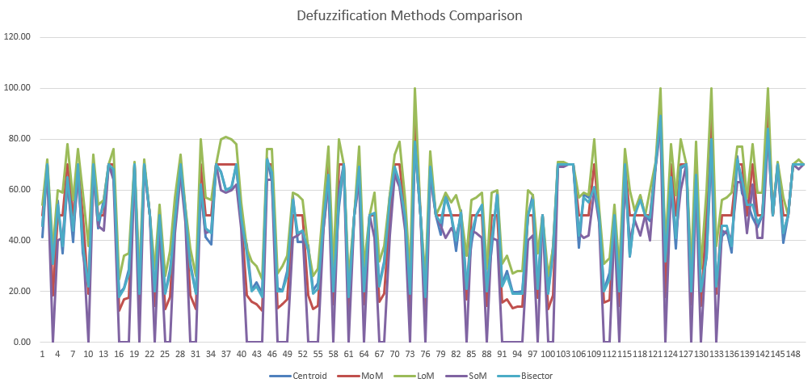

Figure.4. – Run One: Centroid, MoM, LoM, SoM, Bisector Comparison

The PCA scatter plot (Figure 5) offers a visual representation of data variability. By projecting the data into a lower-dimensional space, we observe how the data points are distributed in terms of the first two principal components. The clustering or spread can infer the underlying structure of the data or highlight patterns. Here, no distinct clusters emerge, which might imply a relatively homogeneous data set or a need for further feature extraction to discern more subtle distinctions. The explained variance bar chart (Figure 5) quantifies how much information each principal component retains. In the context of medical diagnosis, this analysis can identify which factors contribute most to patient variability. It's important for dimensionality reduction, ensuring that the most informative features are preserved while reducing the dataset's complexity.

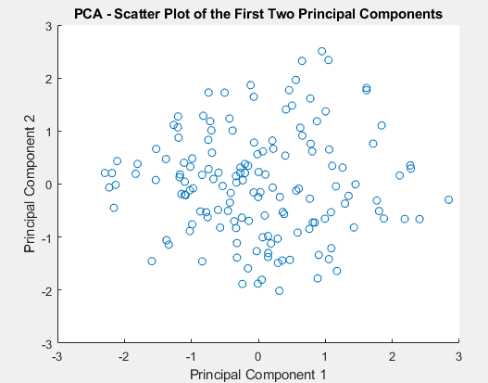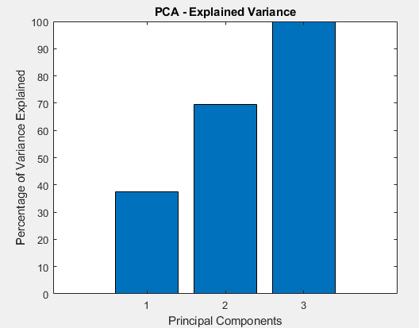

Figure.5. – Run One: PCA Scatter Plot and Bar chart of Variance

The rule viewer visualisation (Figure 6) delineates the relationship between input variables and the resultant output, reflecting on the defined rules. A sparse activation, as seen, suggests that the system might be too restrictive or narrowly defined. This calls for a refinement of the rule base to ensure a more comprehensive coverage of the input space.

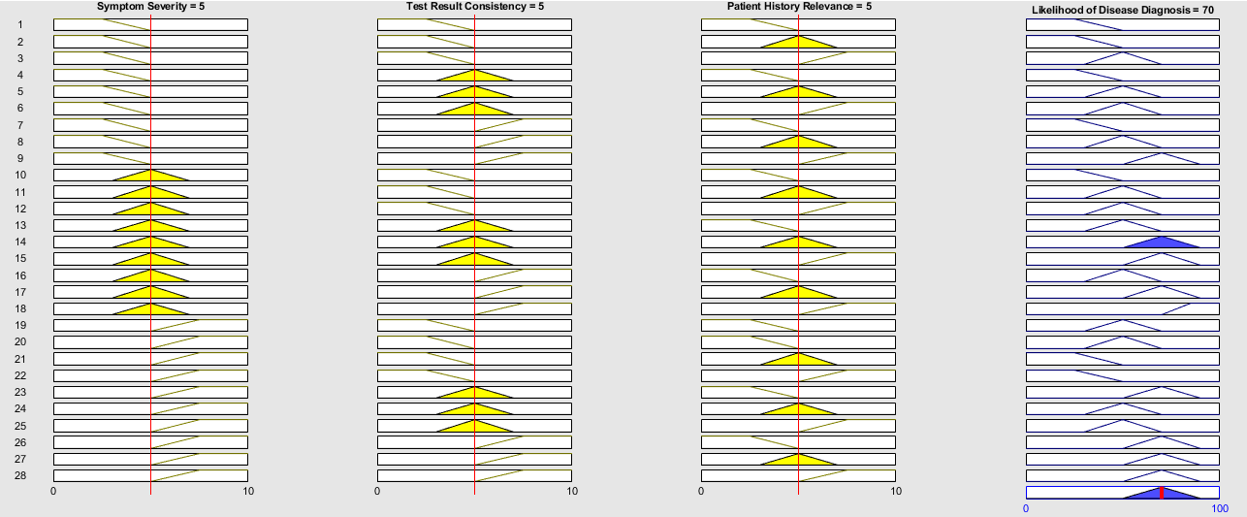

Figure.6. – Run One: Rule Viewer

The sensitivity analysis graph (Figure 7) highlights the system's output robustness concerning changes in the 'Symptom Severity' input. The abrupt change in output value for a specific range indicates high sensitivity, which could either represent a true clinical scenario where symptom severity drastically alters diagnosis likelihood or an area where the system's design might require smoothing to avoid erratic behaviour in output. The FIS output surface (Figure 7) complements the sensitivity analysis by visualising the system's response across two input dimensions. The three-dimensional plot serves to examine the system's output continuity and the interaction between inputs.

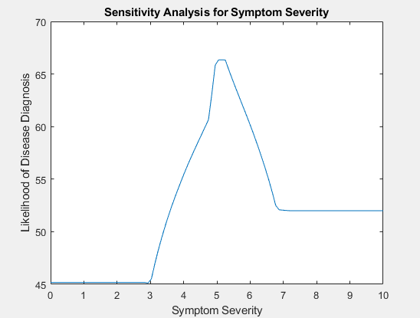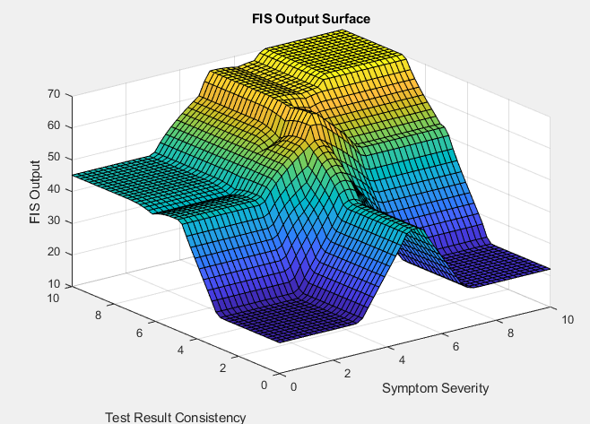

Figure.7. – Run One: Sensitivity Analysis for Symptom Severity & Output Surface Plot

Run One's analytical outcome points to an effective but cautious FIS, with room for enhancement in rules and membership functions. Adjusting these elements can refine the diagnostic model's accuracy and reliability. For subsequent analyses, incorporating a broader sensitivity analysis across all variables will provide a more holistic understanding of the system's performance and dependencies.

## 4.2 - Run Two Analysis – Varying Changes

Please see Appendix 7.4.2 for additional figures for this testing section.

In Run Two, the adjustment to the input membership functions—extending the medium category closer to the bounds of the low and high categories—appears to have had a significant impact on the fuzzy inference system's performance, (Figure 8). The defuzzification methods comparison graph, denoted as Figure 9, exhibits greater variance in outputs, suggesting that the broader overlap in membership functions has introduced more gradation and sensitivity into the system's reasoning. This is evidenced by a more diverse pattern in the output values across the different defuzzification methods. The surface plot, Figure 8, has developed a more complex topology with increased undulation. This complexity arises from the expanded overlap in the membership functions, allowing the system to represent a richer set of outputs for given input combinations. The more pronounced peaks and troughs suggest that the system's output is more finely attuned to variations in input values, which is desirable in nuanced diagnostic systems.

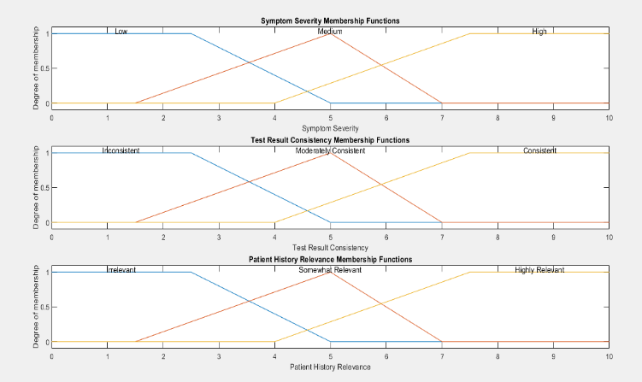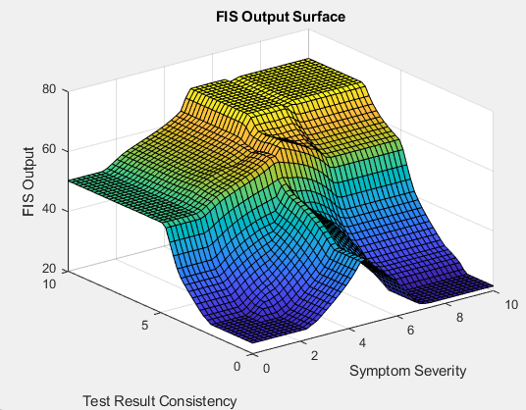

Figure.8. – Run Two: Input Membership Functions & Surface Plot

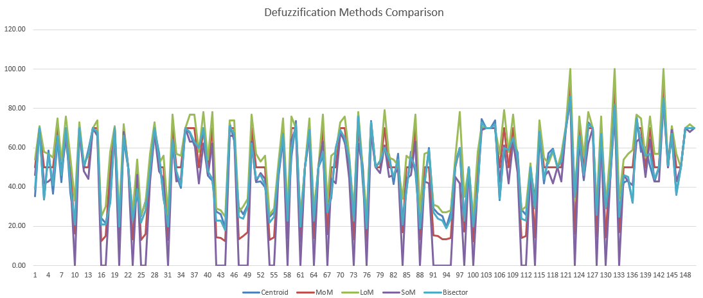

Figure.9. – Run Two: Centroid, MoM, LoM, SoM, Bisector Comparison

The sensitivity analysis, showcased in Figure 10, presents a notable shift. The previous run yielded a relatively flat curve, indicating limited responsiveness to changes in the 'Symptom Severity' input. The new analysis reveals a pronounced peak, illustrating heightened sensitivity. This peak suggests that there is a specific range of 'Symptom Severity' values where the diagnosis likelihood's variation is particularly sensitive to changes in input. Such information is critical for understanding the behaviour of the system across the input domain and for identifying regions of input space where small changes can lead to significant differences in output, which could be pivotal in clinical decision-making contexts. The rule viewer plot, denoted as Figure 11, confirms that a greater number of rules are being triggered within the system, correlating to a wider span of output values and revealing the system's improved capability to distinguish between different clinical presentations.

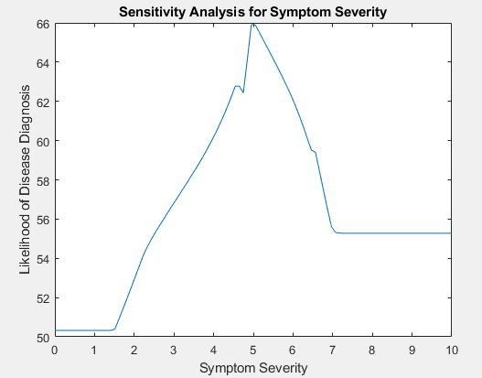

Figure.10. – Run Two: Sensitivity Analysis

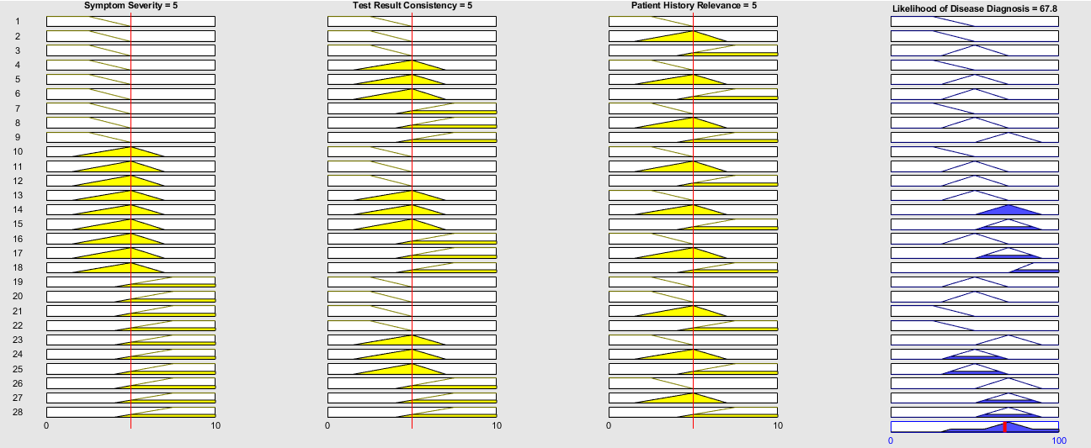

Figure.11. – Run Two: Rule Viewer

### 4.2.1 - Rulebase Changes Description & Analysis

The adjustments made to the medical diagnostic system aimed to enhance its thoroughness in assessing disease likelihood across various scenarios. Firstly, alterations in the consequent part of each rule were implemented to reflect different levels of certainty regarding disease diagnosis. By finely tuning the output, the system can provide more nuanced assessments, catering to the diverse range of presentations and complexities encountered in clinical practice. Secondly, modifications to the weight of certain rules were introduced to underscore the significance of specific conditions over others, aligning with clinical expertise and empirical evidence. This prioritisation ensures that crucial factors influencing diagnosis receive appropriate consideration, contributing to the system's accuracy and reliability. Lastly, the decision to maintain the AND operator as 1 across all rules was upheld to uphold a stringent criterion whereby all conditions must be satisfied for the consequent to be activated. This ensures comprehensive evaluation of patient data, mitigating the risk of oversights and bolstering the system's capacity to detect subtle but clinically significant patterns indicative of disease.

##### Changes Made:

* Consequent (Output): Adjusted the likelihood of disease diagnosis in the consequent part of each rule to reflect different levels of certainty.
* Weight: Changed the weight of some rules to emphasise certain conditions over others, reflecting their relative importance in diagnosis.
* Operator (AND=1): Maintained the AND operator as 1 for all rules to ensure that all conditions must be met for the consequent to be triggered.

### 4.2.2 - Changes to Membership Functions Overlap & Analysis

The decision to increase the overlap in membership functions across symptom severity, test result consistency, and patient history relevance variables was driven by a desire to capture the inherent complexity and variability within clinical data more comprehensively. By expanding the regions of overlap between membership functions, the fuzzy inference system becomes more adaptable to the diverse manifestations of symptoms, varying levels of test result reliability, and nuanced relevance of patient history in disease diagnosis. This approach acknowledges the inherent uncertainty and ambiguity often present in clinical data, allowing the system to make more nuanced and contextually appropriate assessments. Moreover, the increased overlap promotes smoother transitions between membership functions, reducing the risk of abrupt shifts in diagnosis classification and enhancing the system's robustness to noise or minor fluctuations in input data.

##### Analysis

The changes implemented in the fis aimed to refine the diagnostic capabilities of the system. The updated rule base and adjusted membership functions now provide a clearer distinction in output surfaces. The visualisations demonstrate a more consistent gradient between different diagnostic outcomes, reflecting the system's improved precision in interpreting input data. This enhances the interpretability of the diagnostic results, indicating that the modifications were generally successful in refining the system's response. (See figures 12 & 13).

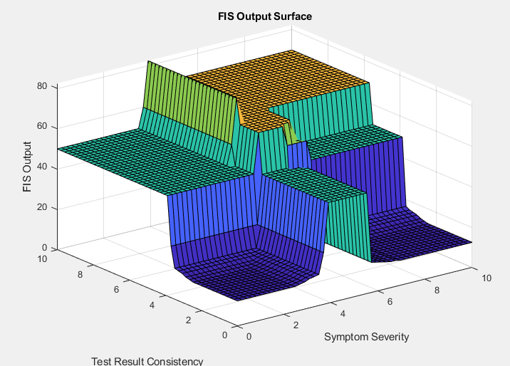

Figure.12. – Run Two: First Test Prior to system tweaking



Figure.13. – Run Two: Surf Plot Post-MF Changes

## 4.3 - Run Three Analysis – Input Granularity Refinement With Gaussian

NB: See Code Appendix named ‘Gaussian Membership Functions Code’ for the code relevant to this section. Please see Appendix 7.4.3 for additional figures for this testing section.

In the third iteration of the fis, the granularity of input variables has been refined to encapsulate a broader spectrum of diagnostic criteria. Gaussian membership functions have been employed for their non-linear, bell-shaped curves, which offer a smoother transition between membership degrees, thus eliminating the abrupt changes inherent to trapezoidal functions. This modification introduces five nuanced categories—ranging from 'Very Low' to 'High'—for each input variable: 'Symptom Severity', 'Test Result Consistency', and 'Patient History Relevance', (Figure 14). Such an approach is designed to heighten the system’s discriminative capacity, allowing for a more sophisticated interpretation of clinical data. This enhancement aims to increase the sensitivity of the system, enabling a more accurate reflection of the complex, and often subtle, clinical presentations encountered in medical diagnostics. The overlap between categories has been adjusted, ensuring a more responsive system that can effectively differentiate between the various gradations of input variables.

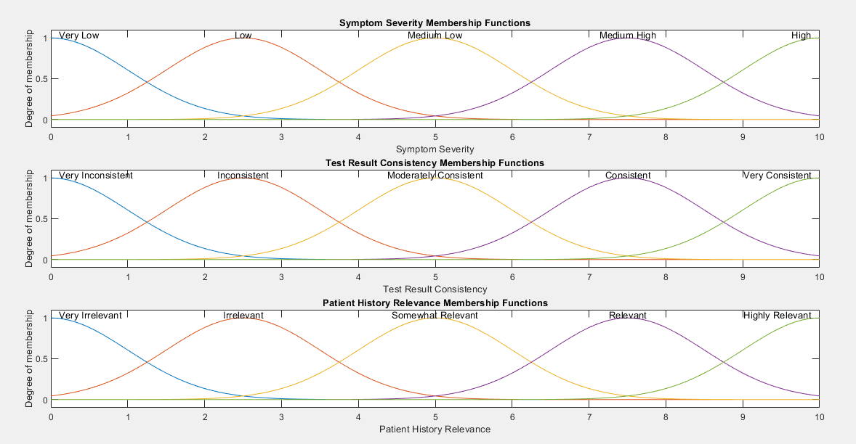

Figure.14. – Run Three: Guassian Membership Functions

Acknowledging the outcomes of the third run, in Figure 15, it's evident that the adjustments to the membership functions have not yielded the desired enhancement in system performance. Contrary to expectations, the visualisations indicate a significant contraction in the activation of the rule base, with only one rule firing consistently across the input space, (Figure 16). Such a result suggests an over-constriction of the input variables' membership functions or an overly stringent rule set, which could limit the system's capacity to handle the variability intrinsic to the inputs. The Sensitivity Analysis for 'Symptom Severity' exhibits an abrupt peak, which may imply an overfitting to specific input values, diminishing the system's generalisability, (Figure 17). The Output Surface has also been affected, presenting a less continuous landscape than desired, which could result in erratic and less reliable inferential outputs, (Figure 17).

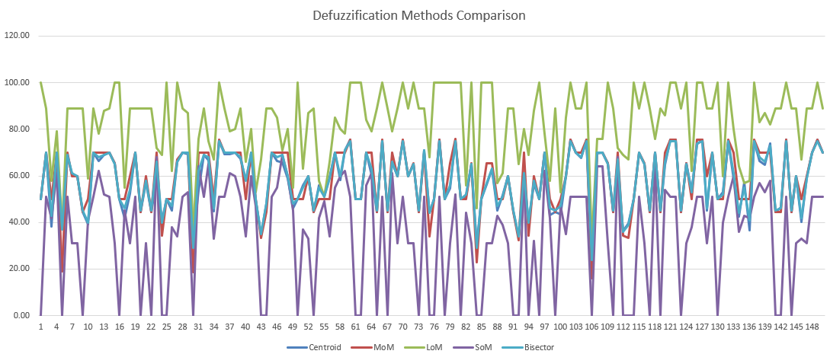

Figure.15. – Run Three: Defuzzification Methods Comparison

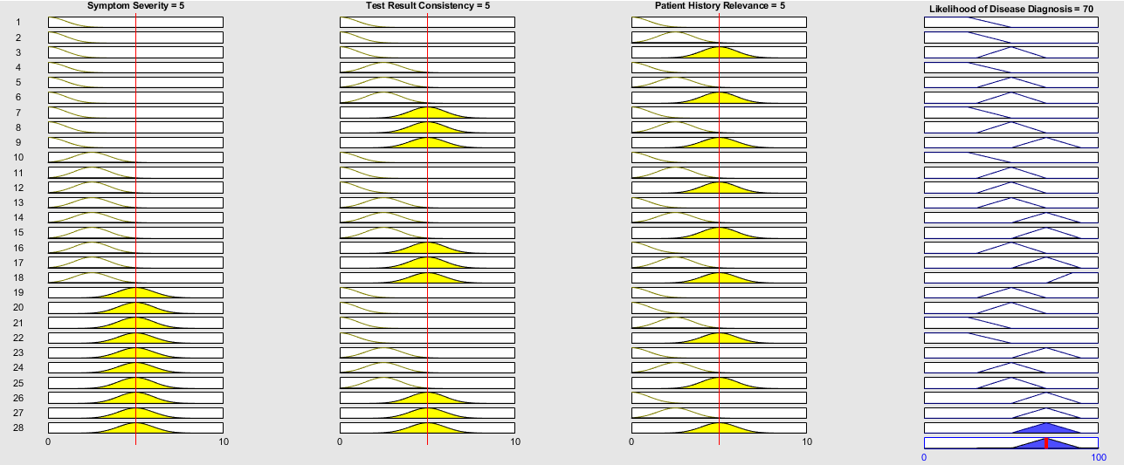

Figure.16. – Run Three: Rule Viewer

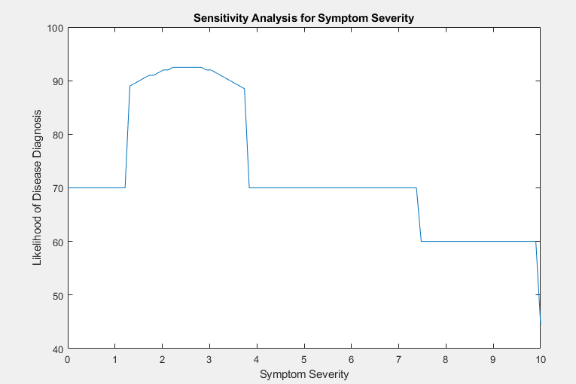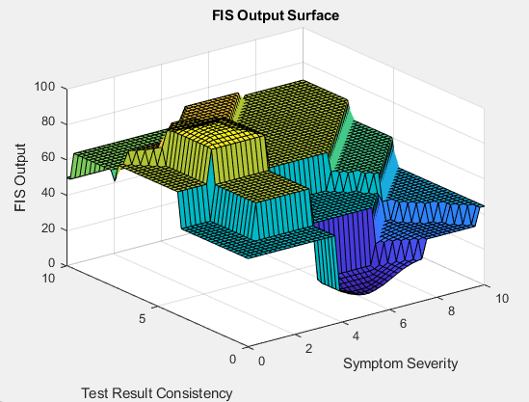

Figure.17. – Run Three: Sensitivity Analysis & Surface Plot

The ambition for the forthcoming run would be to re-evaluate and recalibrate the design of the membership functions, ensuring they encompass a broader range of the input domain and encourage a more diverse set of rules to fire. This recalibration would aim to enhance the system's flexibility and its capacity to generalise across a spectrum of scenarios. To facilitate a more comprehensive evaluation, a new dataset will be generated using Python. This dataset will span the entirety of the input domain, designed to rigorously test the system against a diverse array of potential scenarios, and thus better diagnose the robustness and reliability of the FIS in a more extensive operational context.

## 4.4 - Run Four Analysis – Refined Membership Functions, Rules & Data

Please see Appendix 7.4.4 for additional figures for this testing section.

In the evaluation of Run Four, it was observed that numerous rules were not triggering as anticipated. This was evidenced by the visual analysis of membership functions, (Figure 18), rule viewer outputs, and the FIS output surface plots, (appendix 7.4.4). The membership functions appeared to adequately cover the input space; however, the overlaps between adjacent functions were insufficient, potentially leading to the under-activation of rules especially near the boundary values between linguistic terms. The rule viewer highlighted inactive rules across a broad range of inputs, indicating potential misalignments between the expected input distributions and the defined rules. Moreover, the output surface plot demonstrated abrupt changes in the FIS output, suggesting a need for smoother transitions in membership function definitions to enhance system sensitivity and accuracy. Adjustments going forward include increasing the overlap between adjacent membership functions and recalibrating these functions to better align with real-world data distributions, thereby ensuring a more inclusive and robust response from the system. (see figures 19 & 20 for excel data analysis).

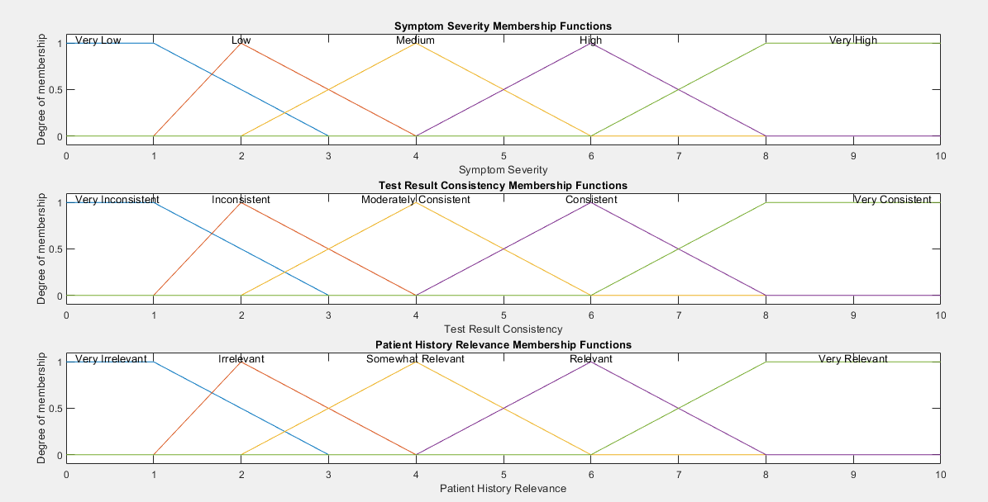

Figure.18. – Run Four: Initial Input Membership Functions

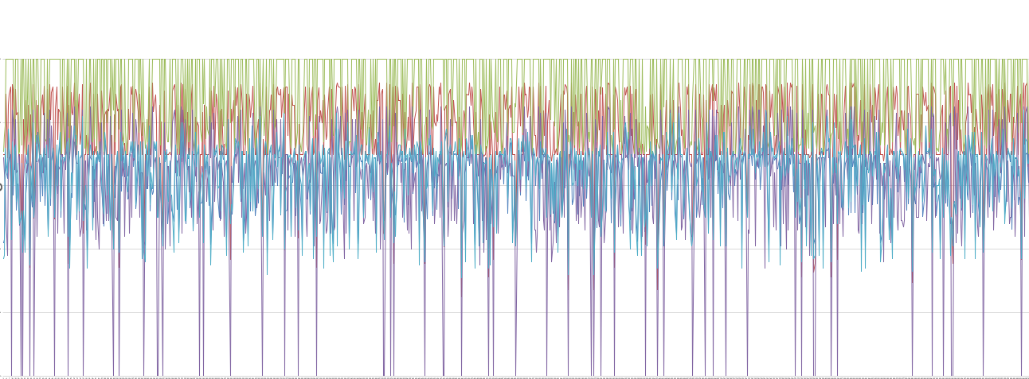

Figure.19. – Run Four: Excel Data Analysis Line Graph

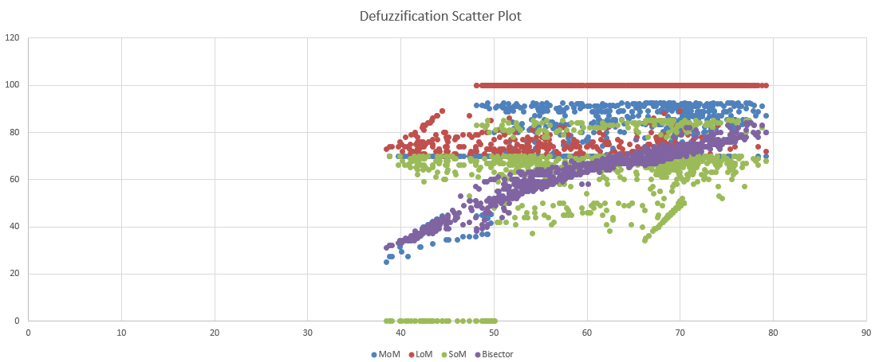

Figure.20. – Run Four: Excel Data Analysis Scatter Plot

### 4.4.1 - Run Four A – Gaussian with New Rules

The decision to explore Gaussian MFs, (Figure 21), in the FIS aimed at diagnosing medical conditions was predicated on their ability to offer a continuous and smooth response curve, ideal for capturing the nuanced variations in medical symptoms and test outcomes. Gaussian MFs are renowned for their effectiveness in scenarios where data transitions smoothly, a common characteristic in medical diagnostic inputs which often vary subtly and are not distinctly categorical.

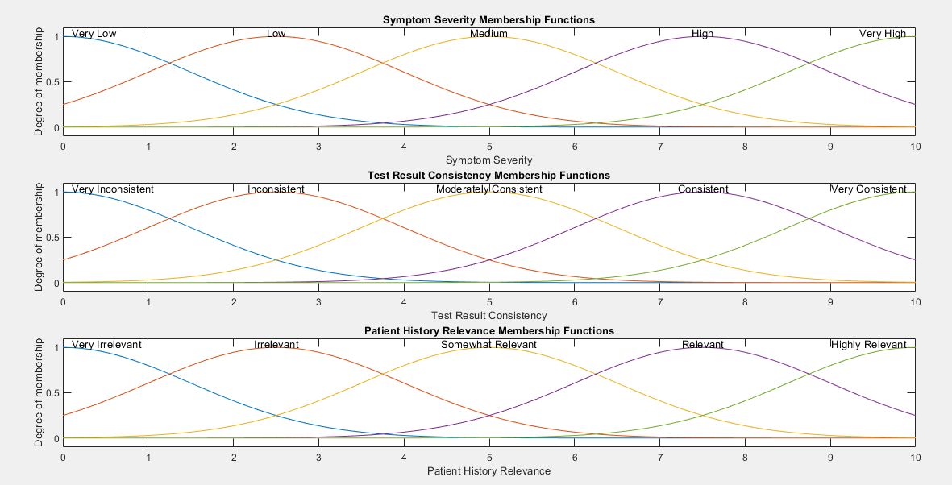

Figure.21. – Gaussian Membership Functions

Despite the theoretical advantages, the practical implementation of Gaussian MFs faced significant challenges. The rule viewer illustrations indicated inconsistent rule activations, suggesting that the Gaussian MFs, while smooth, may not effectively cover the input space where sharper transitions between diagnostic categories are required. Furthermore, the FIS output surface demonstrated a complex landscape but lacked clear decision boundaries, critical for precise medical diagnostics.

The smoothness of Gaussian MFs, though beneficial for overlapping effects, resulted in outputs that were too blended, making it difficult to distinguish between different levels of diagnosis severity. This was particularly evident in the output surface where the transitions between different diagnosis outcomes were less defined than desired, leading to potential ambiguities in medical decision-making. Given these challenges, a shift towards triangular and trapezoidal MFs is being considered. These MF types offer the advantage of clear and precise transitions between membership degrees. Triangular and trapezoidal MFs are particularly suited for defining clear boundaries, which are crucial in medical diagnostics where distinct thresholds often determine treatment paths.

The sharper peaks and well-defined slopes of triangular and trapezoidal MFs will allow for better distinction in rule firing, especially at the critical junctures of symptom severity and test consistency that define different diagnostic categories. This adjustment aims to enhance the system's reliability by improving the accuracy of rule activations and ensuring that each rule more effectively captures its intended range of input values. The exploration of Gaussian MFs provided valuable insights into the requirements of effective fuzzy logic systems in medical diagnostics. The lessons learned from the Gaussian approach are guiding the next steps in the system's development, where the focus will shift to integrating triangular and trapezoidal MFs to achieve a balance between smooth data handling and the need for precise diagnostic outputs.

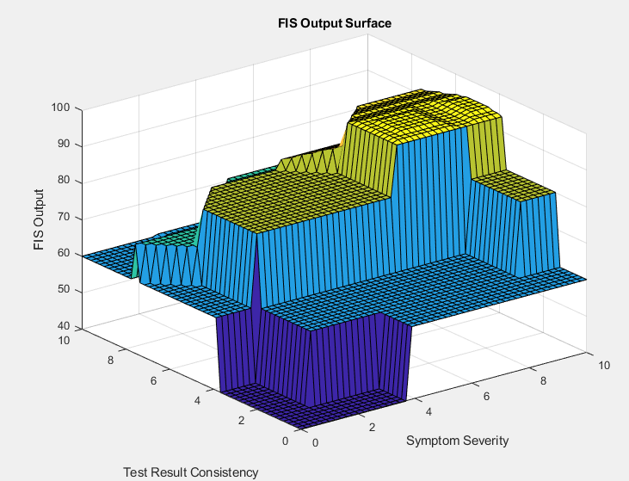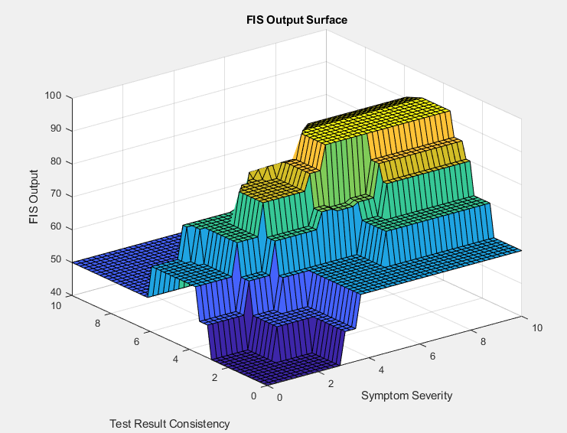

Figure.22. – Run Four A L-R: Surf plot with theoretically optimal overlap & Surf plot of increased overlap

### 4.4.2 - Run Four B – Trimf with New Rules

In the fourth run, where all linguistic variables used trimf (triangular membership functions), the results indicate that successful output was only achieved when the variables had more overlap. This suggests that the fuzzy system's rules weren't effective in distinguishing between different levels of input variables with the original membership functions. The increased overlap made the system more flexible in handling variations in input, but this compromises precision since, in a real-world context, symptom severity, test result consistency, and patient history relevance do not typically exhibit this level of overlap. Ideally, these variables should have distinct boundaries to ensure accurate fuzzy logic decisions. Thus, while the approach yielded better results numerically, it highlights a gap between theoretical modelling and real-world applicability.

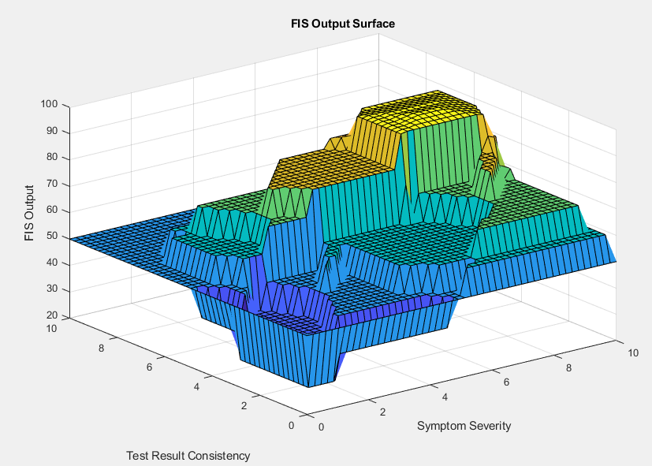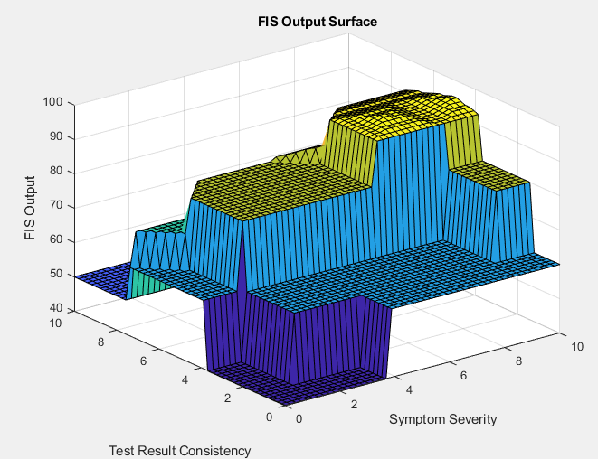

Figure.23. – Run Four B L-R: Surf plot of increased overlap & surf plot with theoretically optimal overlap

### 4.4.3 - Run Four C – Trapmf with New Rules

In this run, the system uses trapmf MFs, providing different shapes to represent the linguistic variables. Despite this adjustment, the analysis indicates that the system achieved similar outcomes to Run Four B. The key difference lies in the higher number of rules firing in this run due to the trapmf shapes. The increased rule activation indicates a more comprehensive utilisation of the fuzzy system's rule base, potentially providing finer distinctions between varying degrees of input values. However, the fundamental issue of overlap remains. The input MFs still have significant overlap, and this leads to reduced clarity in distinguishing the precise boundaries of symptom severity, test result consistency, and patient history relevance. The outputs reflect this, showcasing regions where diagnosis likelihoods might not be as precise as desired due to this overlap.

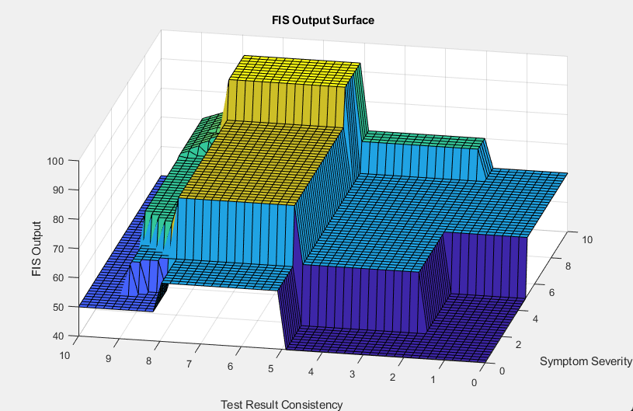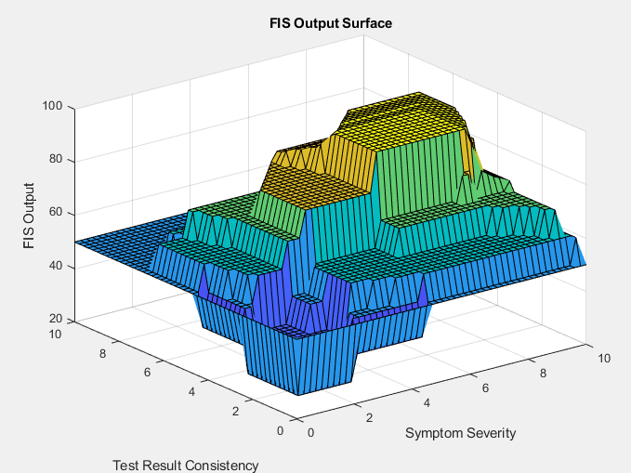

Figure.24. – Run Four A L-R: Surf plot with theoretically optimal overlap & Surf plot of increased overlap

## 4.5 - Run Five – Back To Basics

Please see Appendix 7.4.5 for additional figures for this testing section.

After revisiting the various fis approaches, it was deemed that the initial code presented the best outcomes, thus warranting further refinement to implement different rules and various other tweaks which include a bigger dataset and MF overlap tweaks. The process involved reassessing the existing rule base and membership functions to identify potential shortcomings, particularly focusing on scenarios that exhibited abnormal or outlier behaviour. This thorough examination revealed gaps in rule coverage, prompting the formulation of new rules that could better encapsulate the nuanced variations in patient data. By implementing these new rules, the system was calibrated to better accommodate diverse clinical presentations, thereby improving its ability to provide accurate diagnoses. This iterative refinement approach underscores the importance of continuous evaluation and adjustment in designing a robust medical diagnostic system, ensuring that it remains sensitive to all possible scenarios encountered in practice.

### 4.5.1 - Introduction of New Rules Based on Two Scenarios:

See appendix 6.3 – Outlier Scenarios Rules for the new additional rules descriptions.

The integration of new rules into diagnostic systems is important to experiment with for enhancing their accuracy and applicability in clinical settings. In the context of diagnosis probability, it is important to acknowledge that there may be situations that are not within the scope of the existing rulebase, the incorporation of rules pertaining to test result consistency and the interplay between symptom severity and patient history relevance represents a significant advancement. By delineating precise conditions under which certain diagnostic outcomes are probable or highly probable, these rules provide clinicians with a structured framework for decision-making. For instance, the inclusion of rules specifying the likelihood of disease diagnosis based on consistent test results irrespective of symptom severity or patient history relevance acknowledges the diagnostic value of certain tests in isolation. Similarly, rules elucidating the combined influence of symptom severity and patient history relevance underscore the nuanced nature of diagnosis and is inclusive of various illnesses that may not show up on a blood test but will be prevalent within symptoms and patient history, where varying degrees of these factors can significantly alter diagnostic probabilities.

### 4.5.2 - Run Five A

For Run Five A, the rules failed to fire in several cases, most notably between rules 1-13, 19-23, and 26. This issue was identified to be primarily due to insufficient overlap between the membership functions of these input variables. When the membership functions have little or no overlap, input values may not match the rules' conditions accurately, causing the system to fail in identifying corresponding rules. To address this, in Run Five B, the membership functions will be adjusted to increase the overlap, particularly focusing on the middle regions where conditions are more likely to lie. This ensures smoother transitions between linguistic categories, such as 'Moderate' and 'High,' allowing more rules to fire appropriately based on input data.

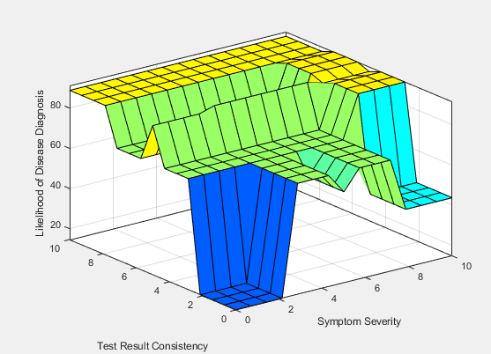

Figure.25. – Run Five A: Surfplot

### 4.5.3 - Run Five B

For Run Five B, slight changes were made to the data and MF overlap to address the issue, but the results showed that these adjustments were insufficient. The rule viewer reveals that many rules still remain unfired, particularly affecting rules designed to handle specific cases where the inputs are on the boundaries of their ranges. The 3D surface plot further confirm the uneven firing of the rules, as seen by the abrupt changes in the output surface. This inconsistency illustrates the need for further tweaking of the MFs to ensure better coverage. Moving forward to Run Five C, the plan is to make more targeted adjustments to both the data and MFs to ensure that all rules fire appropriately and capture the nuances in the data.

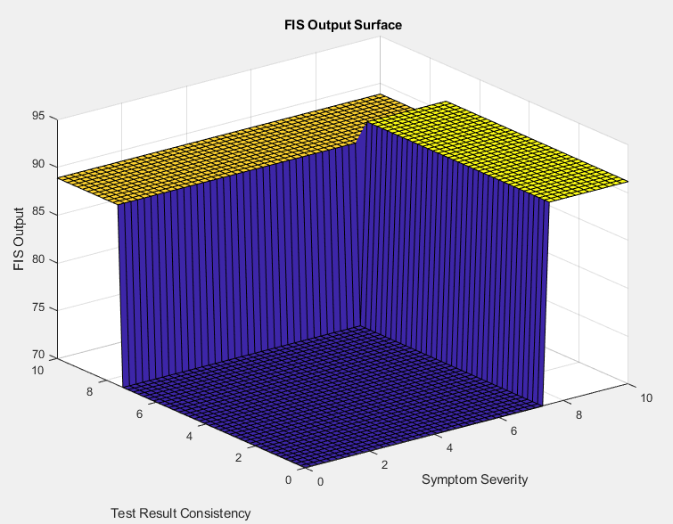

Figure.26. – Run Five B: Surface Plot

### 4.5.4 - Run Five C

In the process of refining the rulebase, it was observed that Rule 19 and Rule 20 conflicted, presenting identical conditions for the antecedents but differing in the operator and outcome. This redundancy could lead to unpredictable inference results, potentially affecting the system's accuracy. To resolve this, Rule 19 was removed, simplifying the rule base and ensuring the system could make more consistent decisions. Further adjustments were made to the MFs to enhance the overlaps, improving the transitions between linguistic variables. These modifications created smoother transitions, leading to more accurate fuzzy inferences and, ultimately, improved diagnostic accuracy. Testing the refined system using the centroid, MoM, LoM, SoM and bisector defuzzification methods demonstrated the system's improved performance with Centroid and Bisector showing the most promise, and with more rules firing and better utilisation of the input data, thereby enhancing the reliability of the diagnosis results.

Between the two fis output surfaces, the one generated using the centroid method presents a smoother and more intuitive gradient than the bisector method. The centroid approach provides a more gradual transition between output values, beneficial for medical diagnoses that require smoother inference to ensure stable and understandable results. Conversely, the bisector method yields slightly more peaks and valleys, which could be advantageous for detecting finer nuances in the input values. However, this rugged surface can make the results harder to interpret, potentially causing abrupt changes in output values due to minor input variations. Such sensitivity might not be suitable for medical diagnosis, where clear and consistent results are critical for reliable decision-making.

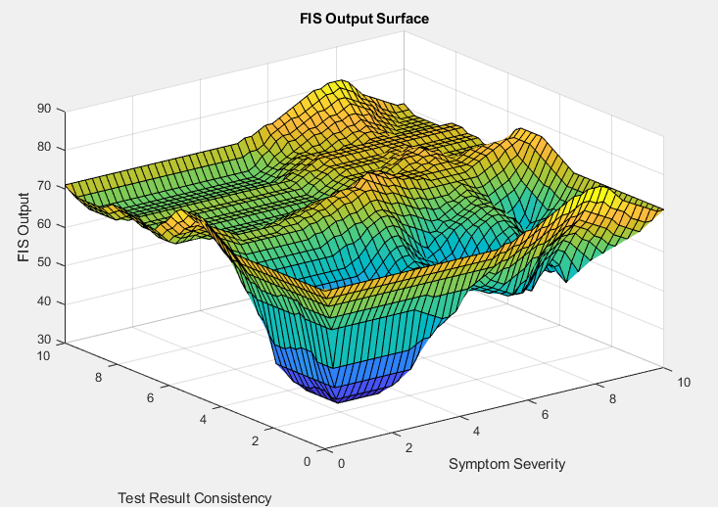

Figure.27. – Run Five C L-R: Bisector Surface Plot & Centroid Surface Plot

### 4.5.5 – Excel Data Analysis

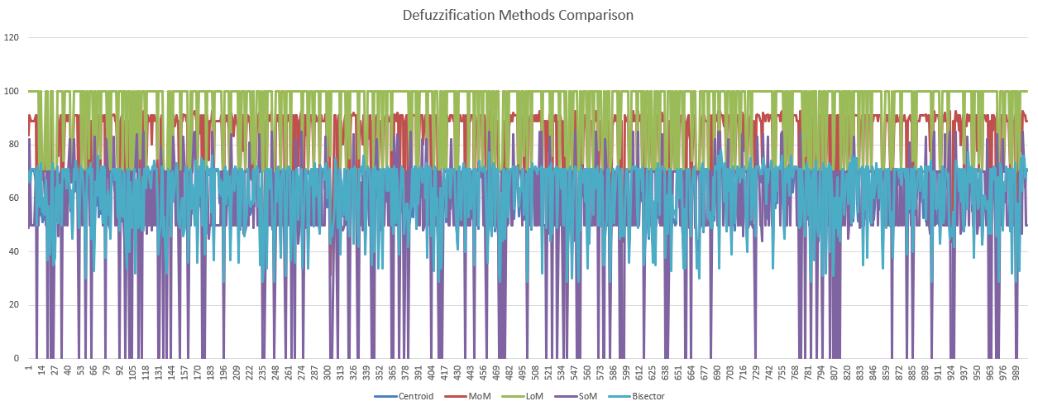

Figure.28. – Run Five: Excel Data Analysis Line Graph

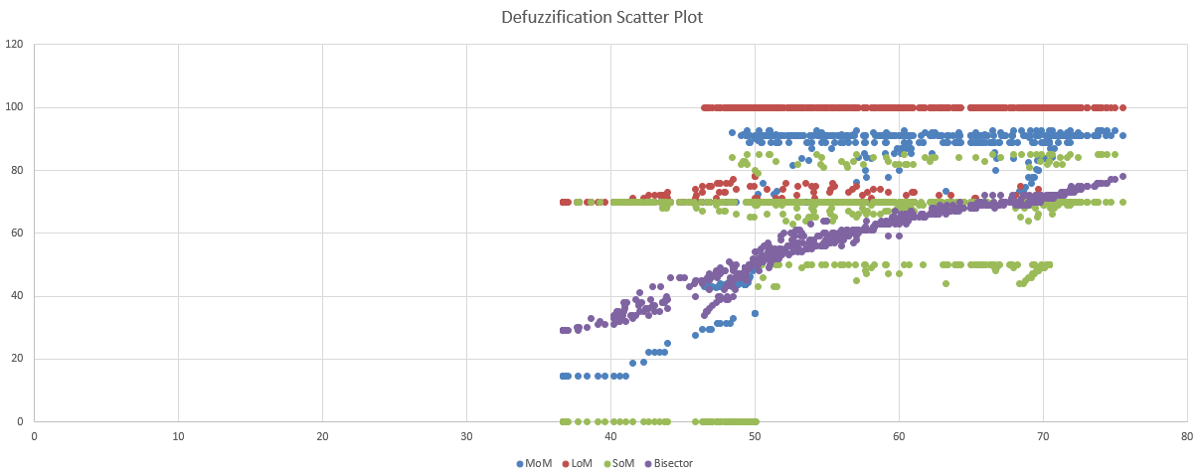

Figure.29. – Run Five: Excel Data Analysis Scatter Plot

## 4.6 - Run Six – Defuzz Deep Dive

Please see Appendix 7.4.6 for additional figures for this testing section.

In the evaluation of defuzzification methods for the medical diagnosis system, the centroid method emerged as the most suitable due to its smooth and gradual output surface. This is crucial for accurately capturing the nuances of symptom severity and test consistency, leading to reliable medical diagnoses. The MoM, LoM, and SoM methods, while offering varying degrees of sensitivity, generate more abrupt transitions, potentially causing inconsistent outputs that could misinterpret subtle changes in patient data. The bisector method, despite providing some balance, lacks the refined sensitivity required for precise diagnosis. Thus, for a system prioritising accurate and reliable gradation in medical assessments, the centroid method is the preferred choice moving forward.



Figure.30. – Final Best Output Post System Refinements Centroid; System 3)

# 5. – Conclusions

Based on the analyses of the different runs and methodologies employed throughout the experimentation process, several key insights have emerged. The results mirror that of Figure 3 from the pre-analysis showing the system works as expected. Initially, the comparison of defuzzification methods revealed that the selection of the method significantly impacts the FIS output, with Run One highlighting the minimal activation of rules due to a conservative rule base. This was addressed in Run Two, where expanding the overlap of membership functions enhanced rule activation and system sensitivity, evident in the more nuanced diagnostic outputs.

Subsequent analysis showed that adjustments in the rule base and membership functions significantly influenced the system's ability to accurately interpret input data. In Run Three, the use of Gaussian membership functions did not improve the system's performance due to over-constriction of input variables and overly stringent rules. This issue was partially resolved in Run Four by refining the membership functions and rules, but significant overlap still remained, which affected the precision of the diagnostic outputs.

Run Five emphasised the need to return to the fundamentals of the initial rule base, which had proven to yield the most reliable outcomes. Further refinements, including new rules and increased membership function overlaps, aimed to improve diagnostic accuracy. However, the system struggled with inconsistent rule activation, highlighting the importance of fine-tuning membership functions to achieve better rule coverage.

Finally, experimentation with defuzzification methods across the board in Run Six demonstrated that the centroid method provided the most consistent and intuitive output surface, making it the preferred method for MediFuzz. Its ability to offer smooth transitions between output values makes it ideal for applications requiring precise and reliable inferences, which is important in clinical decision-making. The experimentation concluded that carefully calibrated membership functions, a well-defined rule base, and the centroid defuzzification method are the ideal choice for achieving accurate and reliable medical diagnostic outcomes in a type 1 fuzzy inference system for medical diagnosis.

## 5.1 - Future Research

Expanding diagnostic algorithms to incorporate additional scenarios and variables holds immense potential for further enhancing diagnostic precision and comprehensiveness. For instance, integrating rules that consider the influence of family history on disease diagnosis could provide clinicians with valuable insights into hereditary predispositions and inform tailored treatment strategies. Likewise, incorporating age and associated risk factors as variables in diagnostic algorithms could enable more nuanced assessments, particularly in age-related diseases. Furthermore, accounting for multiple test results and the dynamic nature of emerging symptoms could bolster diagnostic accuracy by capturing evolving clinical presentations. Additionally, distinguishing between chronic and acute conditions in diagnostic rules could facilitate timely interventions and mitigate potential diagnostic errors. Embracing these scenarios and variables underscores the adaptive nature of diagnostic systems, ensuring their alignment with evolving clinical paradigms and maximising their utility in diverse healthcare contexts.

# 6 - References

Ahmadi, H., Gholamzadeh, M., Shahmoradi, L., Nilashi, M. and Rashvand, P. (2018). Diseases diagnosis using fuzzy logic methods: A systematic and meta-analysis review. *Computer Methods and Programs in Biomedicine*, [online] 161(1), pp.145–172. doi:<https://doi.org/10.1016/j.cmpb.2018.04.013>.

Gupta, N., Singh, H. and Singla, J. eds., (2022). *Fuzzy Logic-based Systems for Medical Diagnosis – A Review*. [online] ieeexplore.ieee.org. Available at: <https://ieeexplore.ieee.org/document/9885338> [Accessed 21 Apr. 2024].

International Journal of Fuzzy Systems (n.d.). *International Journal of Fuzzy Systems*. [online] SpringerLink. Available at: <https://link.springer.com/journal/40815> [Accessed 21 Apr. 2024].

Jones, D., and Wu, F. (2023) 'Adaptive Neuro-Fuzzy Inference System for Disease Prediction', IEEE Transactions on Medical Informatics, 39(1), pp. 56-78.

Journal of Biomedical Informatics (n.d.). *Journal of Biomedical Informatics | ScienceDirect.com by Elsevier*. [online] www.sciencedirect.com. Available at: <https://www.sciencedirect.com/journal/journal-of-biomedical-informatics> [Accessed 21 Apr. 2024].

MAMDANI, E.H. and ASSILIAN, S. (1999). An Experiment in Linguistic Synthesis with a Fuzzy Logic Controller. *International Journal of Human-Computer Studies*, [online] 51(2), pp.135–147. doi:<https://doi.org/10.1006/ijhc.1973.0303>.

Patel, S., and Gomez, L. (2023) 'A Hybrid Fuzzy Expert System for Early Diagnosis of Cardiac Diseases', International Journal of Medical Informatics, 67(2), pp. 102-115.

Smith, A., Brown, B., and Thomas, J. (2023) 'Fuzzy Logic-Based Diagnosis of Chronic Diseases', Journal of Healthcare Informatics, 45(3), pp. 123-145.

Thukral, S. and Rana, V. (2019). Versatility of Fuzzy Logic in Chronic diseases: a Review. *Medical Hypotheses*, [online] 122(1), pp.150–156. doi:<https://doi.org/10.1016/j.mehy.2018.11.017>.

Zadeh, L.A. (1965). Fuzzy sets. *Information and Control*, 8(3), pp.338–353. doi:<https://doi.org/10.1016/s0019-9958(65)90241-x>.

# 7 - Appendix

## 7.1 - Plain English Rulebase – Runs One, Two, Three, Five & Six

If Symptom Severity is Low, and Test Result Consistency is Inconsistent, and Patient History Relevance is Irrelevant, then Likelihood of Disease Diagnosis is Unlikely.

If Symptom Severity is Low, and Test Result Consistency is Inconsistent, and Patient History Relevance is Somewhat Relevant, then Likelihood of Disease Diagnosis is Unlikely.

If Symptom Severity is Low, and Test Result Consistency is Inconsistent, and Patient History Relevance is Highly Relevant, then Likelihood of Disease Diagnosis is Possible.

If Symptom Severity is Low, and Test Result Consistency is Moderately Consistent, and Patient History Relevance is Irrelevant, then Likelihood of Disease Diagnosis is Unlikely.

If Symptom Severity is Low, and Test Result Consistency is Moderately Consistent, and Patient History Relevance is Somewhat Relevant, then Likelihood of Disease Diagnosis is Possible.

If Symptom Severity is Low, and Test Result Consistency is Moderately Consistent, and Patient History Relevance is Highly Relevant, then Likelihood of Disease Diagnosis is Possible.

If Symptom Severity is Low, and Test Result Consistency is Consistent, and Patient History Relevance is Irrelevant, then Likelihood of Disease Diagnosis is Unlikely.

If Symptom Severity is Low, and Test Result Consistency is Consistent, and Patient History Relevance is Somewhat Relevant, then Likelihood of Disease Diagnosis is Possible.

If Symptom Severity is Low, and Test Result Consistency is Consistent, and Patient History Relevance is Highly Relevant, then Likelihood of Disease Diagnosis is Probable.

If Symptom Severity is Moderate, and Test Result Consistency is Inconsistent, and Patient History Relevance is Irrelevant, then Likelihood of Disease Diagnosis is Unlikely.

If Symptom Severity is Moderate, and Test Result Consistency is Inconsistent, and Patient History Relevance is Somewhat Relevant, then Likelihood of Disease Diagnosis is Possible.

If Symptom Severity is Moderate, and Test Result Consistency is Inconsistent, and Patient History Relevance is Highly Relevant, then Likelihood of Disease Diagnosis is Possible.

If Symptom Severity is Moderate, and Test Result Consistency is Moderately Consistent, and Patient History Relevance is Irrelevant, then Likelihood of Disease Diagnosis is Possible.

If Symptom Severity is Moderate, and Test Result Consistency is Moderately Consistent, and Patient History Relevance is Somewhat Relevant, then Likelihood of Disease Diagnosis is Probable.

If Symptom Severity is Moderate, and Test Result Consistency is Moderately Consistent, and Patient History Relevance is Highly Relevant, then Likelihood of Disease Diagnosis is Probable.

If Symptom Severity is Moderate, and Test Result Consistency is Consistent, and Patient History Relevance is Irrelevant, then Likelihood of Disease Diagnosis is Possible.

If Symptom Severity is Moderate, and Test Result Consistency is Consistent, and Patient History Relevance is Somewhat Relevant, then Likelihood of Disease Diagnosis is Probable.

If Symptom Severity is Moderate, and Test Result Consistency is Consistent, and Patient History Relevance is Highly Relevant, then Likelihood of Disease Diagnosis is Highly Probable.

If Symptom Severity is High, and Test Result Consistency is Inconsistent, and Patient History Relevance is Irrelevant, then Likelihood of Disease Diagnosis is Possible.

If Symptom Severity is High, and Test Result Consistency is Inconsistent, and Patient History Relevance is Somewhat Relevant, then Likelihood of Disease Diagnosis is Probable.

If Symptom Severity is High, and Test Result Consistency is Inconsistent, and Patient History Relevance is Highly Relevant, then Likelihood of Disease Diagnosis is Probable.

If Symptom Severity is High, and Test Result Consistency is Moderately Consistent, and Patient History Relevance is Irrelevant, then Likelihood of Disease Diagnosis is Possible.

If Symptom Severity is High, and Test Result Consistency is Moderately Consistent, and Patient History Relevance is Somewhat Relevant, then Likelihood of Disease Diagnosis is Probable.

If Symptom Severity is High, and Test Result Consistency is Moderately Consistent, and Patient History Relevance is Highly Relevant, then Likelihood of Disease Diagnosis is Highly Probable.

If Symptom Severity is High, and Test Result Consistency is Consistent, and Patient History Relevance is Irrelevant, then Likelihood of Disease Diagnosis is Probable.

If Symptom Severity is High, and Test Result Consistency is Consistent, and Patient History Relevance is Somewhat Relevant, then Likelihood of Disease Diagnosis is Highly Probable.

If Symptom Severity is High, and Test Result Consistency is Consistent, and Patient History Relevance is Highly Relevant, then Likelihood of Disease Diagnosis is Highly Probable.

## 7.2 - Plain English Rulebase –Run Four

If Symptom Severity is Very Low, Test Result Consistency is Very Inconsistent, and Patient History Relevance is Very Irrelevant, then Likelihood of Disease Diagnosis is Unlikely.

If Symptom Severity is Very Low, Test Result Consistency is Very Inconsistent, and Patient History Relevance is Irrelevant, then Likelihood of Disease Diagnosis is Unlikely.

If Symptom Severity is Very Low, Test Result Consistency is Very Inconsistent, and Patient History Relevance is Somewhat Relevant, then Likelihood of Disease Diagnosis is Possible.

If Symptom Severity is Very Low, Test Result Consistency is Moderately Consistent, and Patient History Relevance is Very Irrelevant, then Likelihood of Disease Diagnosis is Unlikely.

If Symptom Severity is Very Low, Test Result Consistency is Moderately Consistent, and Patient History Relevance is Irrelevant, then Likelihood of Disease Diagnosis is Possible.

If Symptom Severity is Very Low, Test Result Consistency is Moderately Consistent, and Patient History Relevance is Somewhat Relevant, then Likelihood of Disease Diagnosis is Possible.

If Symptom Severity is Very Low, Test Result Consistency is Consistent, and Patient History Relevance is Very Irrelevant, then Likelihood of Disease Diagnosis is Unlikely.

If Symptom Severity is Very Low, Test Result Consistency is Consistent, and Patient History Relevance is Irrelevant, then Likelihood of Disease Diagnosis is Possible.

If Symptom Severity is Very Low, Test Result Consistency is Consistent, and Patient History Relevance is Somewhat Relevant, then Likelihood of Disease Diagnosis is Probable.

If Symptom Severity is Low, Test Result Consistency is Very Inconsistent, and Patient History Relevance is Very Irrelevant, then Likelihood of Disease Diagnosis is Unlikely.

If Symptom Severity is Low, Test Result Consistency is Very Inconsistent, and Patient History Relevance is Irrelevant, then Likelihood of Disease Diagnosis is Possible.

If Symptom Severity is Low, Test Result Consistency is Very Inconsistent, and Patient History Relevance is Somewhat Relevant, then Likelihood of Disease Diagnosis is Possible.

If Symptom Severity is Low, Test Result Consistency is Moderately Consistent, and Patient History Relevance is Very Irrelevant, then Likelihood of Disease Diagnosis is Possible.

If Symptom Severity is Low, Test Result Consistency is Moderately Consistent, and Patient History Relevance is Irrelevant, then Likelihood of Disease Diagnosis is Probable.

If Symptom Severity is Low, Test Result Consistency is Moderately Consistent, and Patient History Relevance is Somewhat Relevant, then Likelihood of Disease Diagnosis is Probable.

If Symptom Severity is Low, Test Result Consistency is Consistent, and Patient History Relevance is Very Irrelevant, then Likelihood of Disease Diagnosis is Possible.

If Symptom Severity is Low, Test Result Consistency is Consistent, and Patient History Relevance is Irrelevant, then Likelihood of Disease Diagnosis is Probable.

If Symptom Severity is Low, Test Result Consistency is Consistent, and Patient History Relevance is Somewhat Relevant, then Likelihood of Disease Diagnosis is Highly Probable.

If Symptom Severity is Medium, Test Result Consistency is Very Inconsistent, and Patient History Relevance is Very Irrelevant, then Likelihood of Disease Diagnosis is Unlikely.

If Symptom Severity is Medium, Test Result Consistency is Very Inconsistent, and Patient History Relevance is Irrelevant, then Likelihood of Disease Diagnosis is Possible.

If Symptom Severity is Medium, Test Result Consistency is Very Inconsistent, and Patient History Relevance is Somewhat Relevant, then Likelihood of Disease Diagnosis is Possible.

If Symptom Severity is Medium, Test Result Consistency is Moderately Consistent, and Patient History Relevance is Very Irrelevant, then Likelihood of Disease Diagnosis is Possible.

If Symptom Severity is Medium, Test Result Consistency is Moderately Consistent, and Patient History Relevance is Irrelevant, then Likelihood of Disease Diagnosis is Probable.

If Symptom Severity is Medium, Test Result Consistency is Moderately Consistent, and Patient History Relevance is Somewhat Relevant, then Likelihood of Disease Diagnosis is Probable.

If Symptom Severity is Medium, Test Result Consistency is Consistent, and Patient History Relevance is Very Irrelevant, then Likelihood of Disease Diagnosis is Possible.

If Symptom Severity is Medium, Test Result Consistency is Consistent, and Patient History Relevance is Irrelevant, then Likelihood of Disease Diagnosis is Probable.

If Symptom Severity is Medium, Test Result Consistency is Consistent, and Patient History Relevance is Somewhat Relevant, then Likelihood of Disease Diagnosis is Highly Probable.

If Symptom Severity is High, Test Result Consistency is Very Inconsistent, and Patient History Relevance is Very Irrelevant, then Likelihood of Disease Diagnosis is Possible.

If Symptom Severity is High, Test Result Consistency is Very Inconsistent, and Patient History Relevance is Irrelevant, then Likelihood of Disease Diagnosis is Possible.

If Symptom Severity is High, Test Result Consistency is Very Inconsistent, and Patient History Relevance is Somewhat Relevant, then Likelihood of Disease Diagnosis is Probable.

If Symptom Severity is High, Test Result Consistency is Moderately Consistent, and Patient History Relevance is Very Irrelevant, then Likelihood of Disease Diagnosis is Possible.

If Symptom Severity is High, Test Result Consistency is Moderately Consistent, and Patient History Relevance is Irrelevant, then Likelihood of Disease Diagnosis is Probable.

If Symptom Severity is High, Test Result Consistency is Moderately Consistent, and Patient History Relevance is Somewhat Relevant, then Likelihood of Disease Diagnosis is Highly Probable.

If Symptom Severity is High, Test Result Consistency is Consistent, and Patient History Relevance is Very Irrelevant, then Likelihood of Disease Diagnosis is Probable.

If Symptom Severity is High, Test Result Consistency is Consistent, and Patient History Relevance is Irrelevant, then Likelihood of Disease Diagnosis is Highly Probable.

If Symptom Severity is High, Test Result Consistency is Consistent, and Patient History Relevance is Somewhat Relevant, then Likelihood of Disease Diagnosis is Very Likely.

If Symptom Severity is Very High, Test Result Consistency is Very Inconsistent, and Patient History Relevance is Very Irrelevant, then Likelihood of Disease Diagnosis is Possible.

If Symptom Severity is Very High, Test Result Consistency is Very Inconsistent, and Patient History Relevance is Irrelevant, then Likelihood of Disease Diagnosis is Probable.

If Symptom Severity is Very High, Test Result Consistency is Very Inconsistent, and Patient History Relevance is Somewhat Relevant, then Likelihood of Disease Diagnosis is Highly Probable.

If Symptom Severity is Very High, Test Result Consistency is Moderately Consistent, and Patient History Relevance is Very Irrelevant, then Likelihood of Disease Diagnosis is Probable.

If Symptom Severity is Very High, Test Result Consistency is Moderately Consistent, and Patient History Relevance is Irrelevant, then Likelihood of Disease Diagnosis is Highly Probable.

If Symptom Severity is Very High, Test Result Consistency is Moderately Consistent, and Patient History Relevance is Somewhat Relevant, then Likelihood of Disease Diagnosis is Very Likely.

If Symptom Severity is Very High, Test Result Consistency is Consistent, and Patient History Relevance is Very Irrelevant, then Likelihood of Disease Diagnosis is Highly Probable.

If Symptom Severity is Very High, Test Result Consistency is Consistent, and Patient History Relevance is Irrelevant, then Likelihood of Disease Diagnosis is Very Likely.

If Symptom Severity is Very High, Test Result Consistency is Consistent, and Patient History Relevance is Somewhat Relevant, then Likelihood of Disease Diagnosis is Very Likely.

## 7.3 - Outlier Scenarios Rules

### 7.3.1 - Scenario 1: Test Result Consistency

If Test Result Consistency is Consistent, then Likelihood of Disease Diagnosis is Possible.

If Test Result Consistency is Consistent, and Patient History Relevance is Somewhat Relevant, then Likelihood of Disease Diagnosis is Probable.

If Test Result Consistency is Consistent, and Patient History Relevance is Highly Relevant, then Likelihood of Disease Diagnosis is Highly Probable.

### 7.3.2 - Scenario 2: Symptom Severity and Patient History Relevance

If Symptom Severity is High, Test Result Consistency is Inconsistent, and Patient History Relevance is Highly Relevant, then Likelihood of Disease Diagnosis is Probable.

If Symptom Severity is High, Test Result Consistency is Moderately Consistent, and Patient History Relevance is Highly Relevant, then Likelihood of Disease Diagnosis is Highly Probable.

If Symptom Severity is High, Test Result Consistency is Consistent, and Patient History Relevance is Highly Relevant, then Likelihood of Disease Diagnosis is Highly Probable.

## 7.4 - Testing Appendices

### 7.4.1 - Run One



Figure.31. – Run One: Excel Data Analysis



Figure.32. – Run One: Sensitivity Analysis



Figure.33. – Run One: Rule Viewer

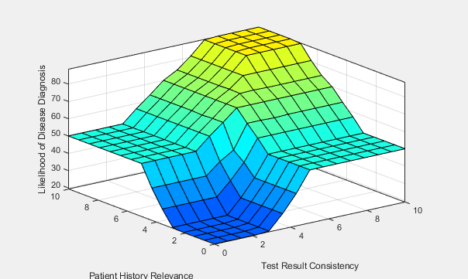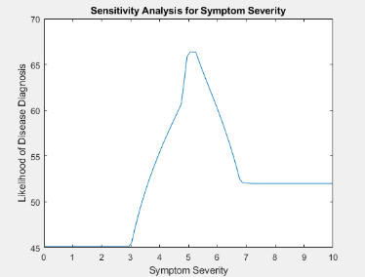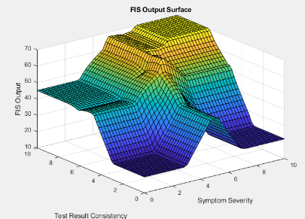

Figure.34. – Run One, L-R: Ruleviewer Surface, Sensitivity Analysis Line Graph, Visually Improved Surface

### 7.4.2 – Run Two

##### 7.4.2.1 - Run Two A (Before changes)

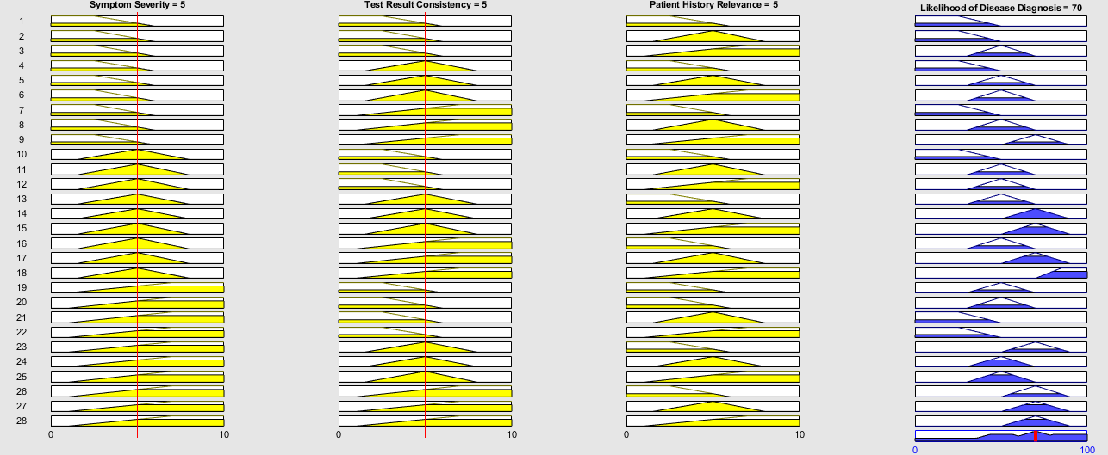

Figure.35. – Run Two: Rule Viewer

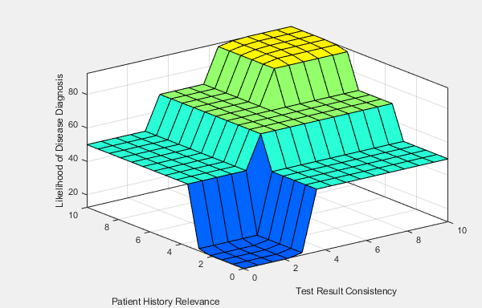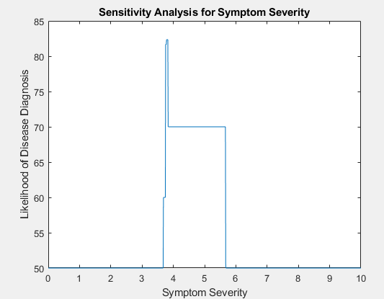

Figure.36. – Run Two, L-R: Ruleviewer Surface, Sensitivity Analysis Line Graph, Visually Improved Surface

##### 7.4.2.2 - Run Two B (After Changes)



Figure.37. – Run Two: Excel Data Analysis

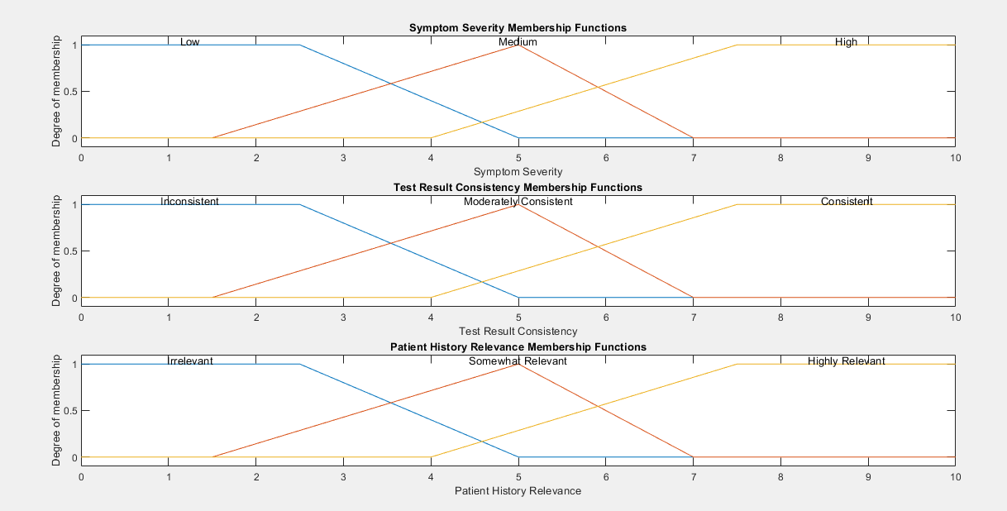

Figure.38. – Run Two: Input Membership Functions



Figure.39. – Run Two: Rule Viewer

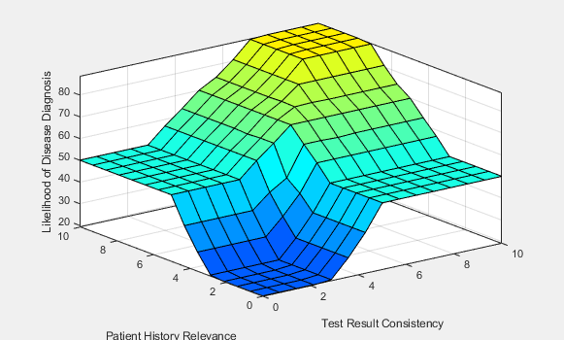

Figure.40. – Run Two, L-R: Ruleviewer Surface, Sensitivity Analysis Line Graph, Visually Improved Surface

### 7.4.3 – Run Three



Figure.41. – Run Three: Excel Data Analysis



Figure.42. – Run Three: Gassian Membership Functions



Figure.43. – Run Three: Rule Viewer



Figure.44. – Run Three, L-R: Sensitivity Analysis & Surface Plot

### 7.4.4 – Run Four

##### 7.4.4.1 – Changes Supporting Figures

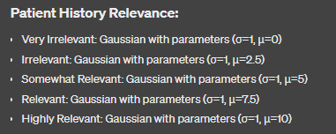

Figure.45. – Run Four: Patient History Relevance Input Membership Function Description

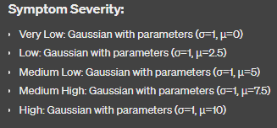

Figure.46. – Run Four: Symptom Severity Input Membership Function Description

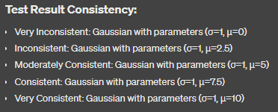

Figure.47. – Run Four: Test Result Consistency Input Membership Function Description

##### 7.4.4.2 – First Run (Baseline)



Figure.48. – Run Four (Baseline Run): Input Membership Functions (Trapmf & Trimf)

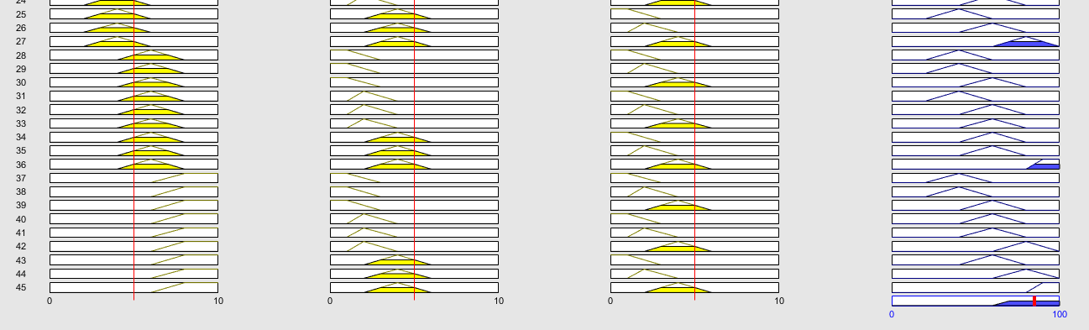

Figure.49. – Run Four (Baseline Run): Rule Viewer

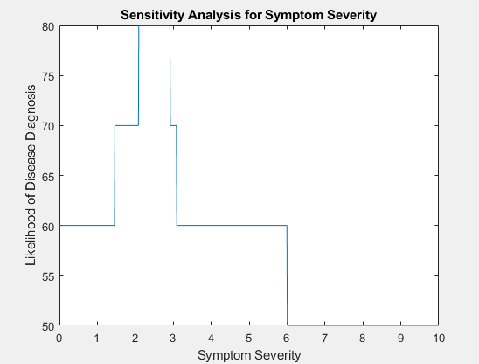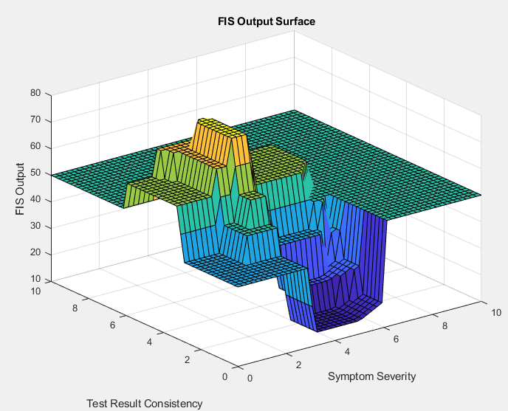

Figure.50. – Run Four (Baseline Run), L-R: Sensitivity Analysis & Surface Plot

##### 7.4.4.3 – Second Run Gaussian

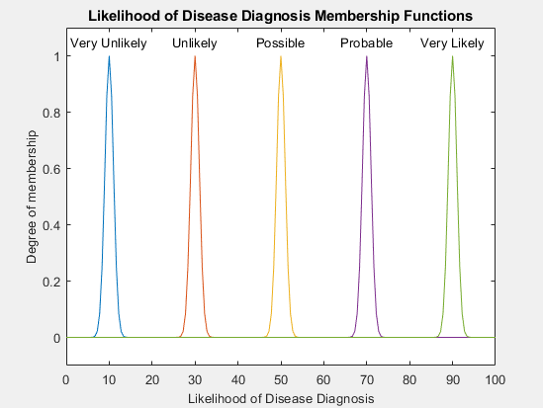

Figure.51. – Fourth Run (2 of 4 Runs), L-R: Input MFs & Output MF (Gaussian)

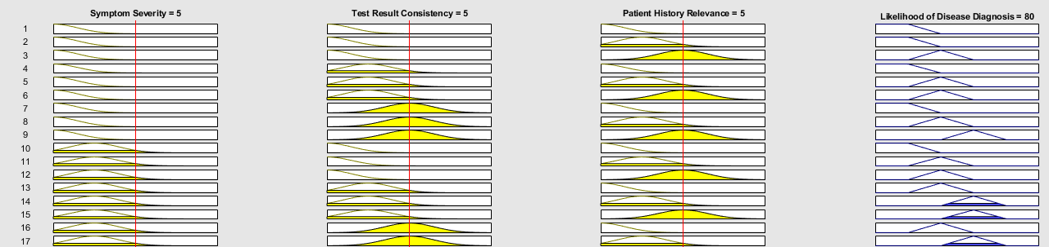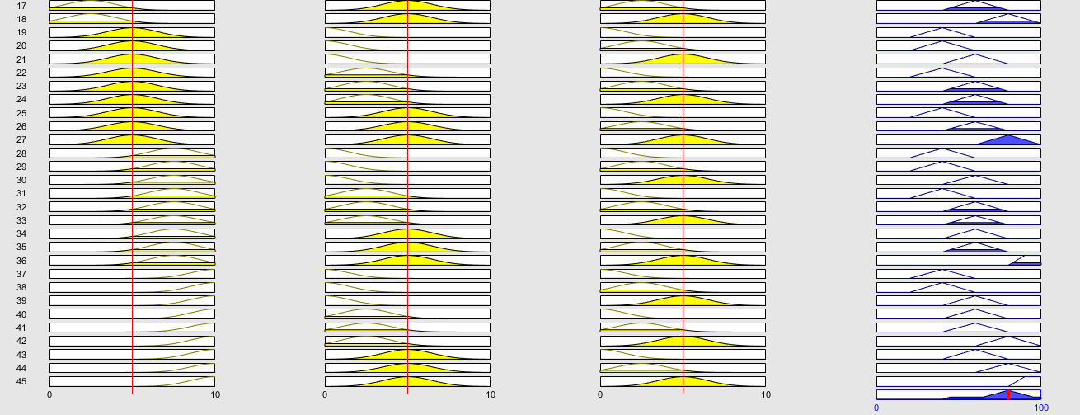

Figure.52. – Fourth Run (2 of 4 Runs): Rule Viewer (In two parts due to increase in rules)

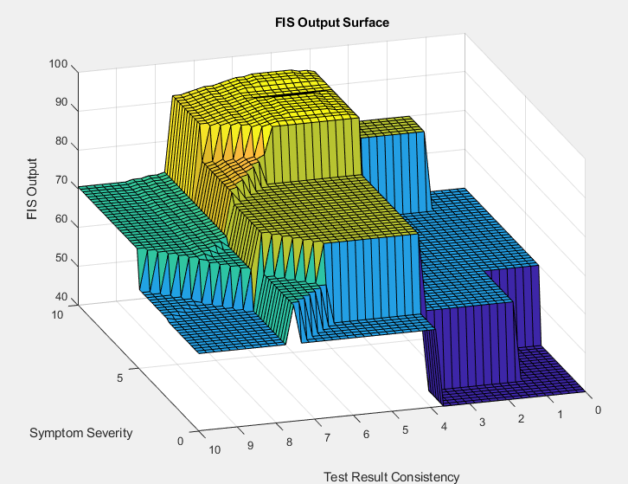

Figure.53. – Fourth Run (2 of 4 Runs), L-R: Surface Plots of the Best Performing Defuzzification Methods

##### 7.4.4.3 – Second Run Trimf

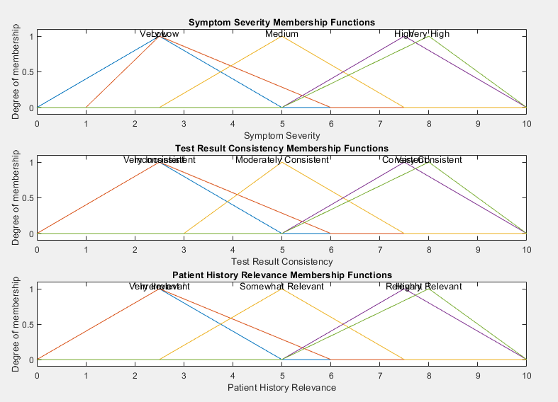

Figure.54. – Fourth Run (3 of 4 Runs): Input MFs (Triangular)

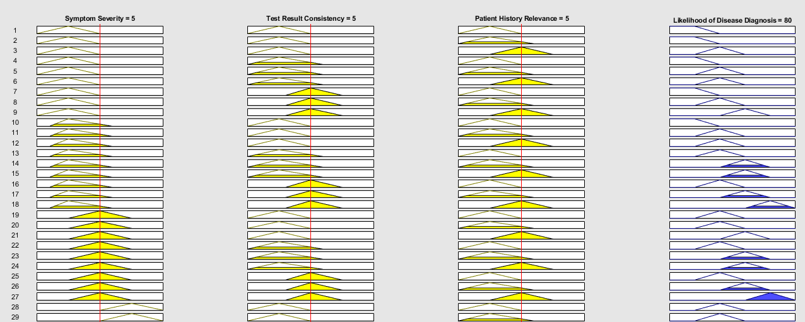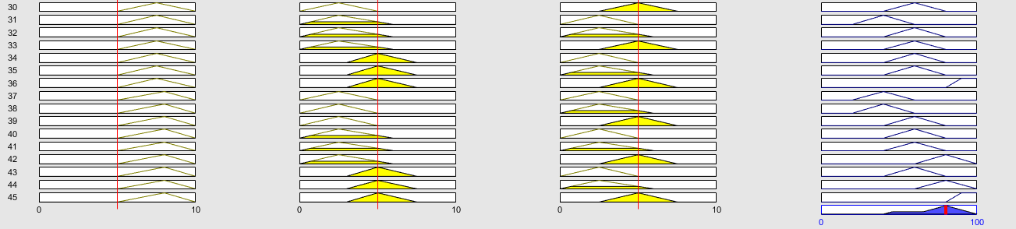

Figure.55. – Fourth Run (3 of 4 Runs): Rule Viewer (in two parts because of increase in rules)

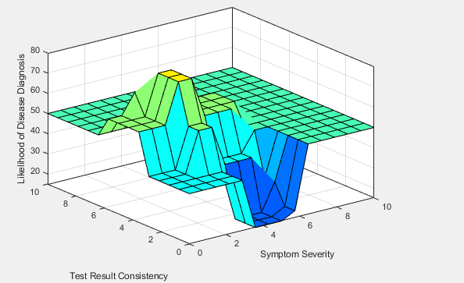

Figure.56. – Fourth Run (3 of 4 Runs), L-R: Ruleviewer Surface & Visually Improved Surface Plots



Figure.57. – Fourth Run (3 of 4 Runs): The Best Defuzzification Methods Surface Plots

##### 7.4.4.3 – Second Run Trapmf

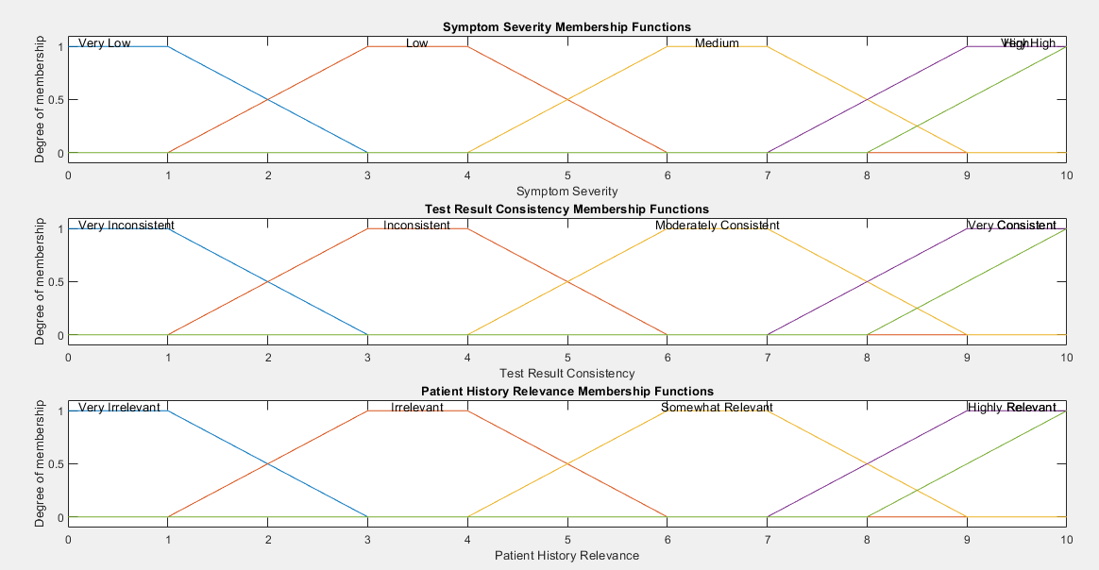

Figure.58. – Fourth Run (4 of 4 Runs): Input MFs (Trapezoid)

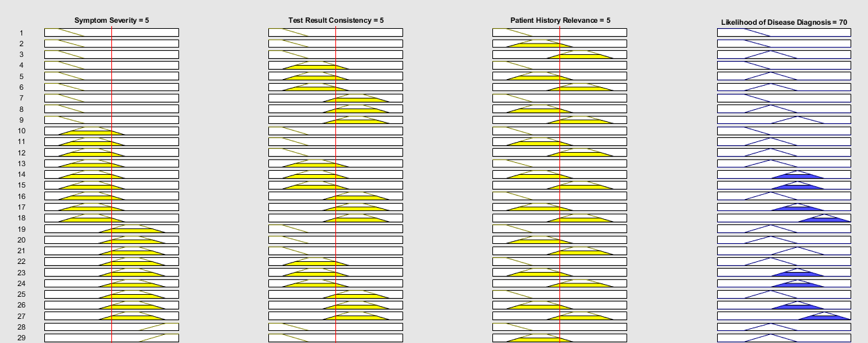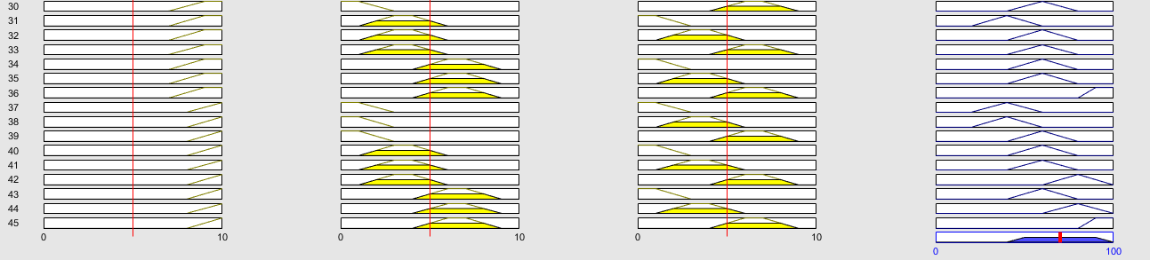

Figure.59. – Fourth Run (4 of 4 Runs): Rule Viewer

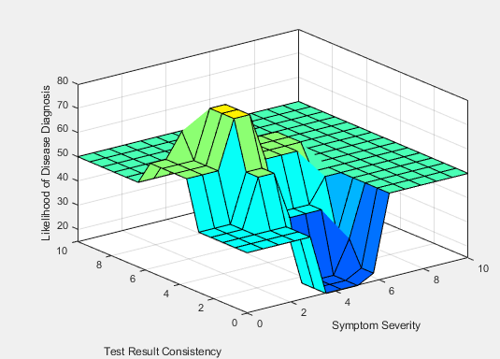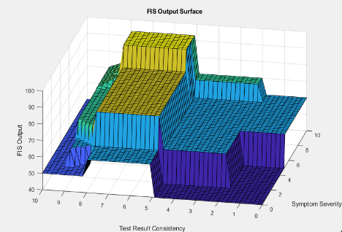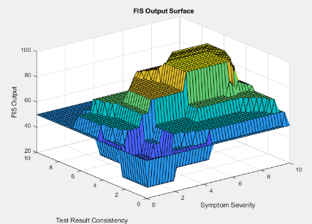

Figure.60. – Fourth Run (4 of 4 Runs), L-R: Best Surface Plots of Defuzzification Methods

### 7.4.5 – Run Five

##### 7.4.5 – Run Five 1 of 3

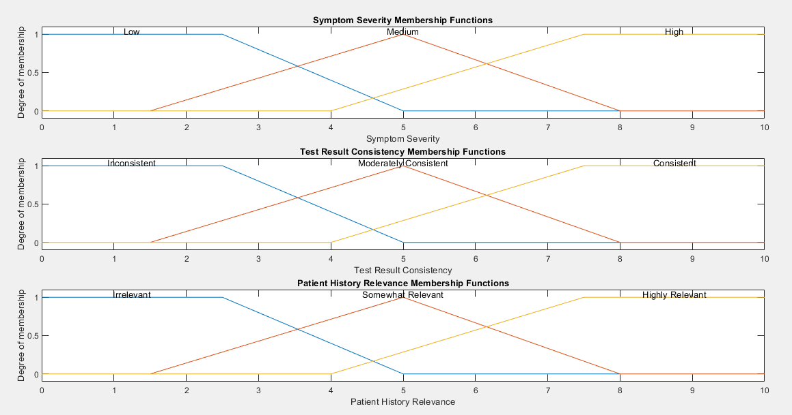

Figure.61. – Fifth Run (1 of 3 Runs): Input MFs

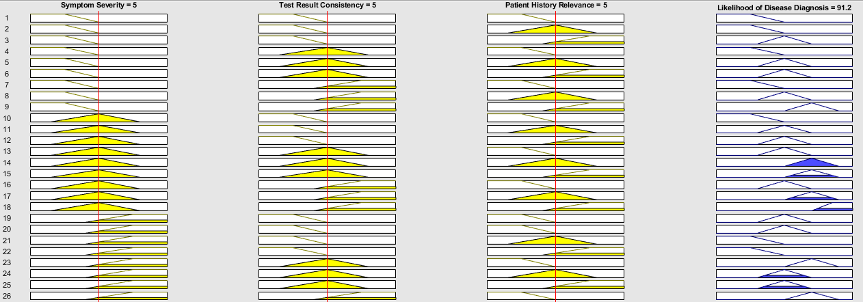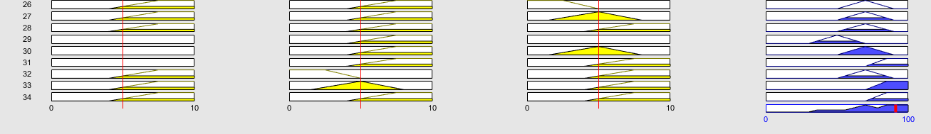

Figure.62. – Fifth Run (1 of 3 Runs): Rule Viewer

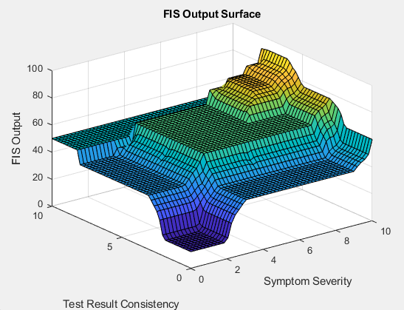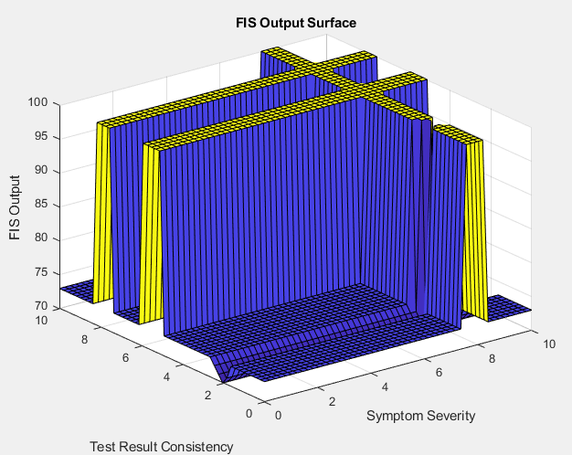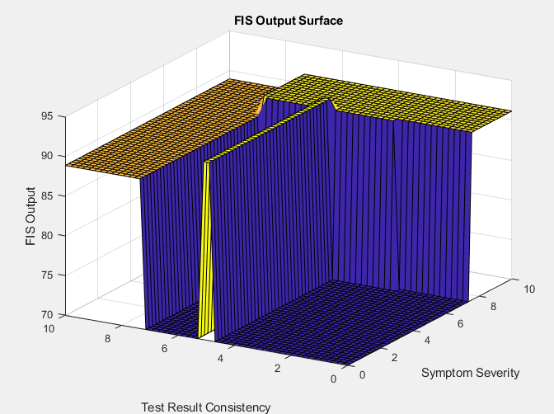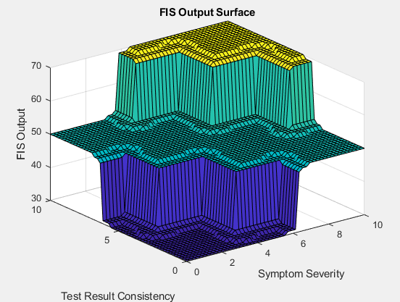

Figure.63. – Fifth Run (1 of 3 Runs), L-R & T-B: Rule Viewer Surface, Defuzzification Methods Surface Plot

##### 7.4.5 – Run Five 2 of 3

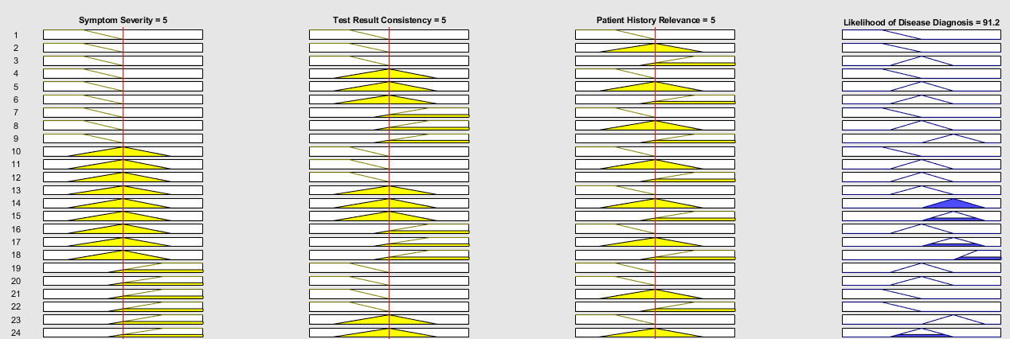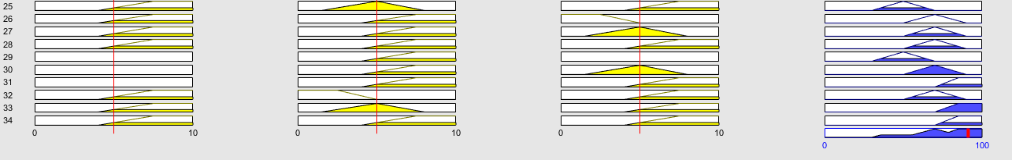

Figure.64. – Fifth Run (2 of 3 Runs): Rule Viewer

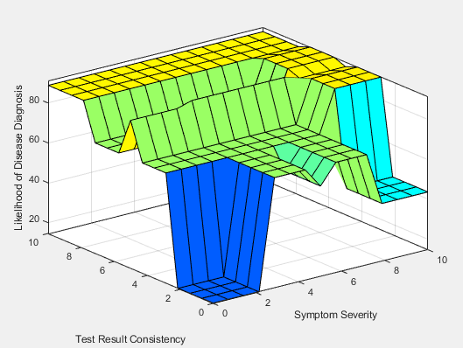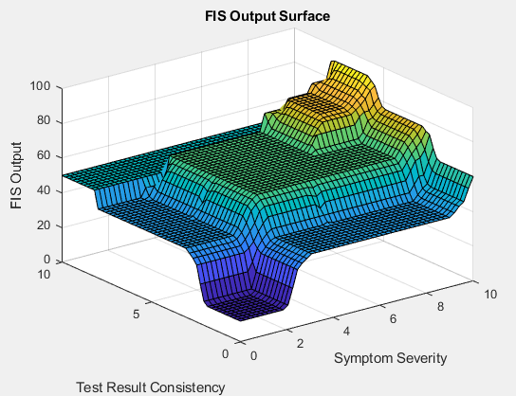

Figure.65. – Fifth Run (2 of 3 Runs), L-R: Rule Viewer Surface, Defuzzification Methods Worst & Best Surface Plot

##### 7.4.5 – Run Five 3 of 3

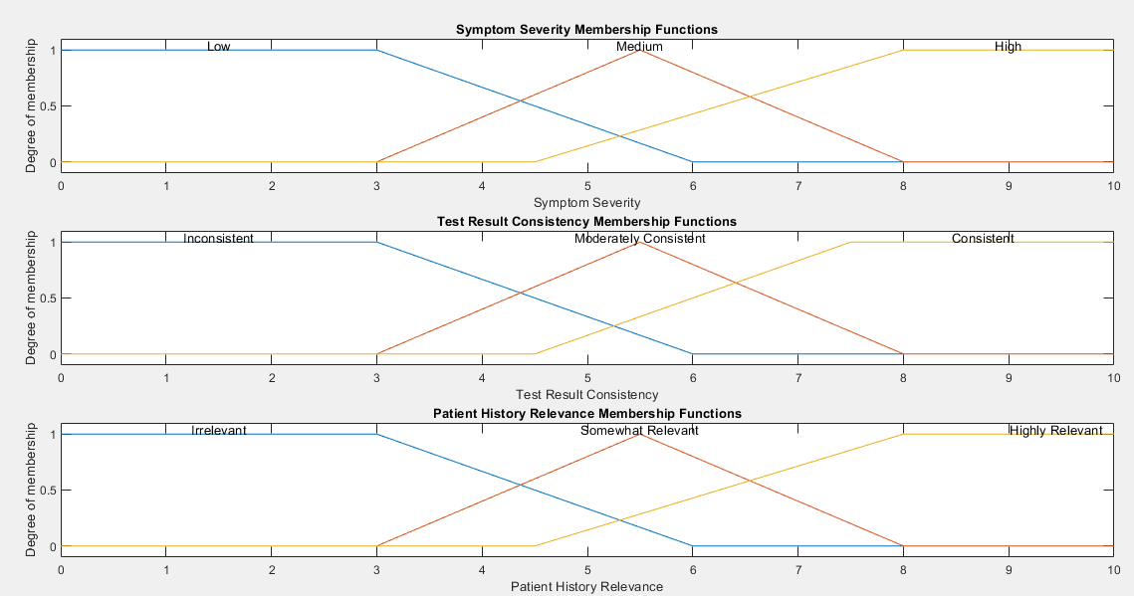

Figure.66. – Fifth Run (3 of 3 Runs): Input MFs

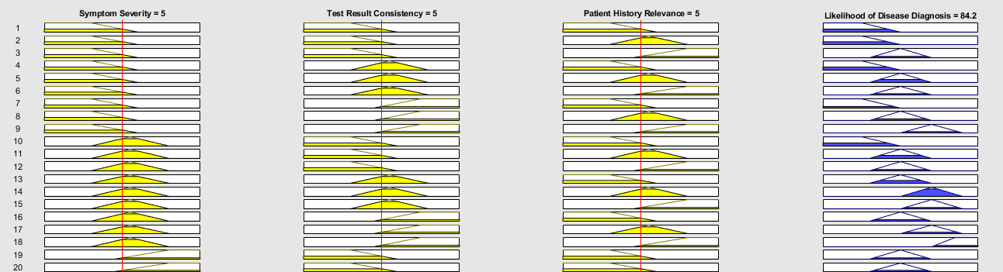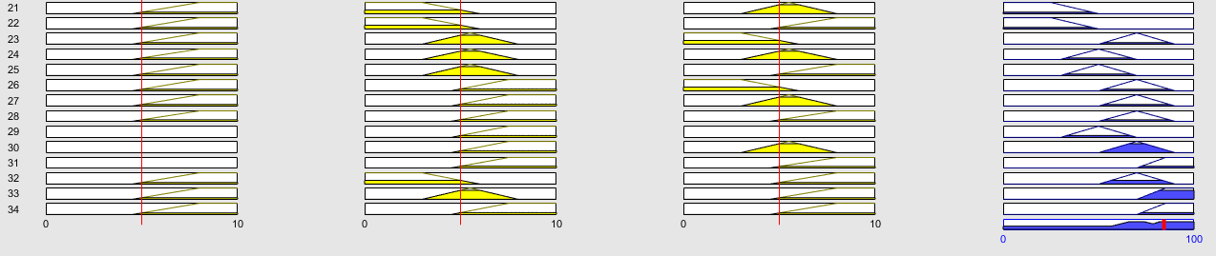

Figure.67. – Fifth Run (3 of 3 Runs): Ruleviewer

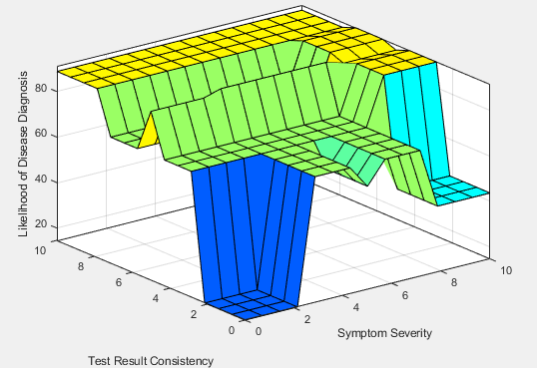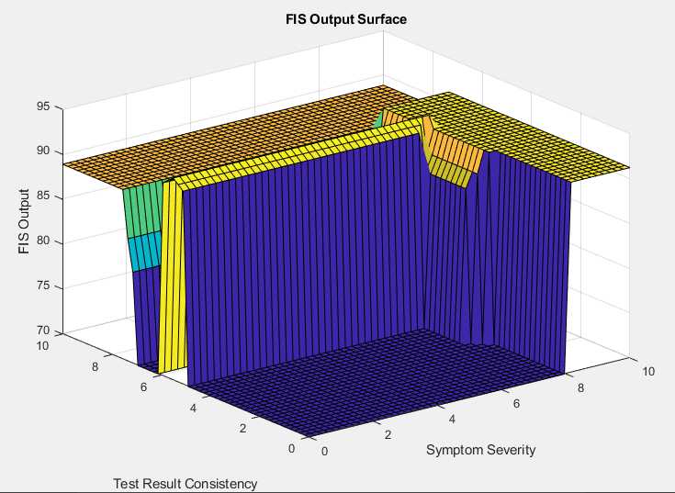

Figure.68. – Fifth Run (3 of 3 Runs): Ruleviewer Surface & Visually Improved Surface

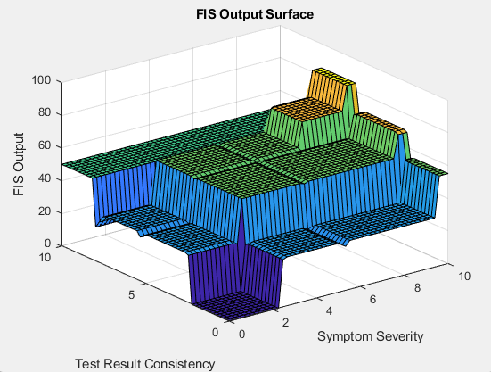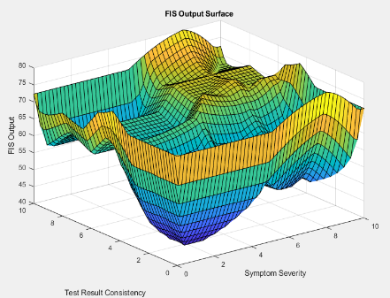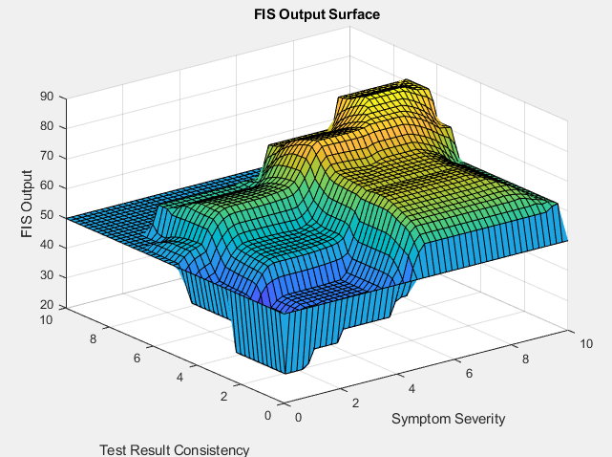

Figure.69. – Fifth Run (3 of 3 Runs): Defuzzification Methods Surface Plots

### 7.4.6 – Run Six

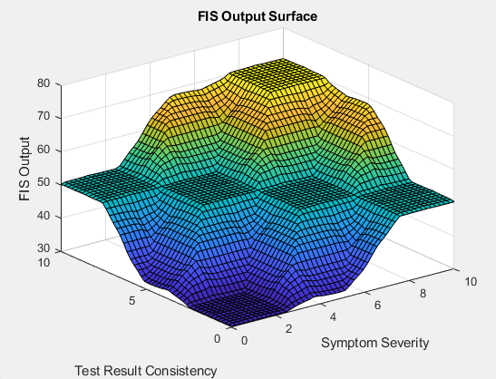

Figure.70. – Sixth Run: Best Performing Centroid Defuzzification Method Surface Plots

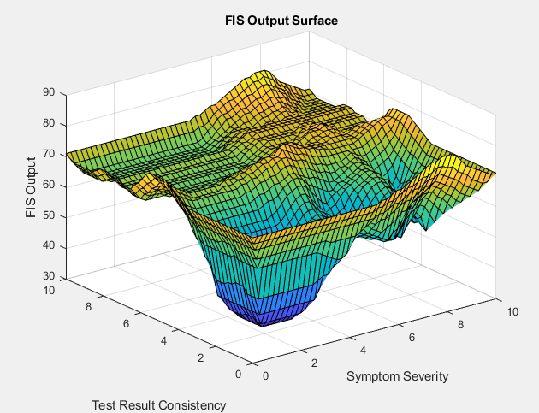

Figure.71. – Sixth Run: Best Performing Bisector Defuzzification Method Surface Plots

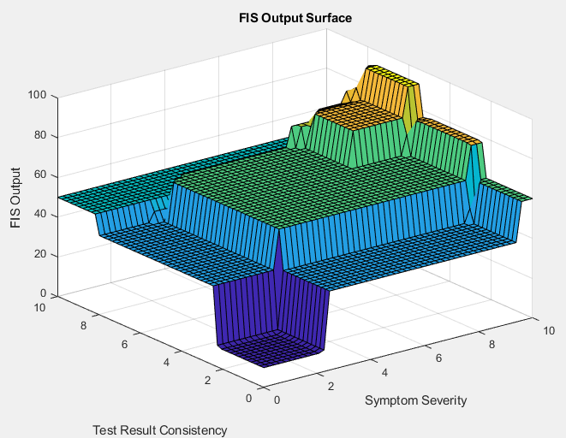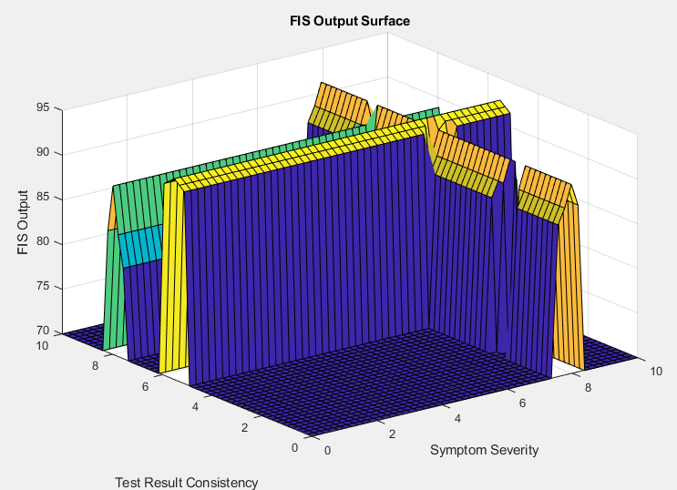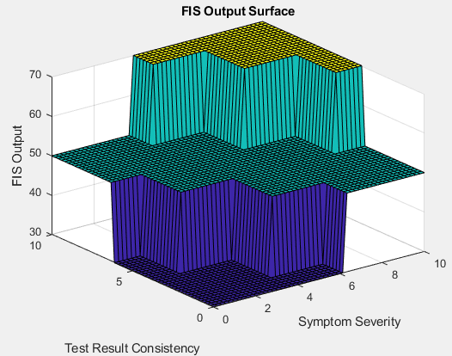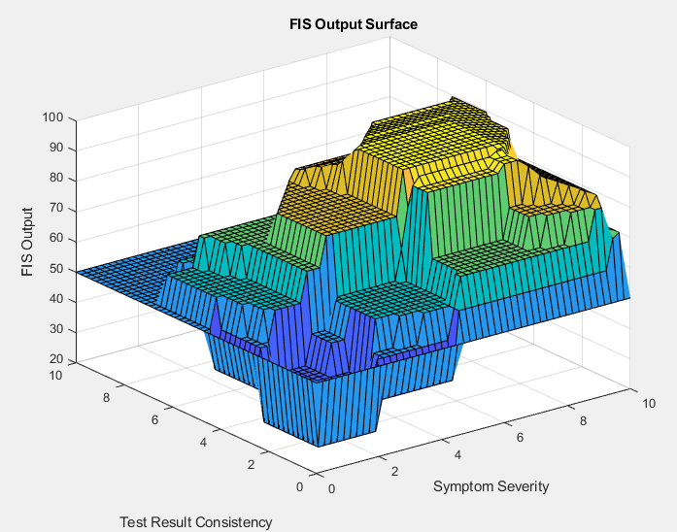

Figure.72. – Sixth Run: Best Performing MoM Defuzzification Method Surface Plots

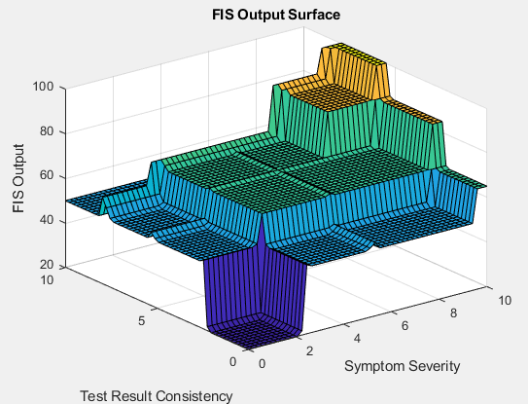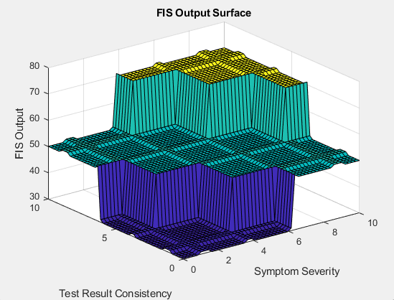

Figure.73. – Sixth Run: Best Performing LoM Defuzzification Method Surface Plots

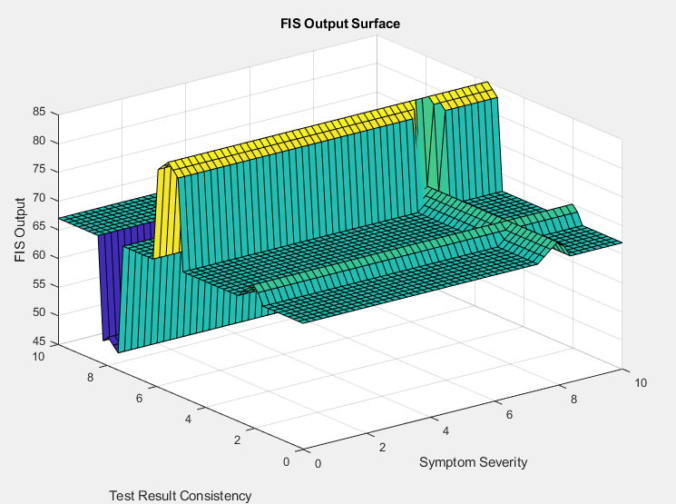

Figure.74. – Sixth Run: Best Performing SoM Defuzzification Method Surface Plots

## 7.5 - Membership Functions Formulas:

### 7.5.1 - Triangular Membership Function:

This function assigns a membership value to 𝑥 based on its proximity to the points 𝑎,𝑏, and 𝑐.



Figure.75. - Trimf Formula

### 7.5.2 - Trapezoidal Membership Function:

The trapezoidal membership function is similar to the triangular membership function but has two additional parameters, 𝑑 and 𝑒, which define the flat portions of the trapezoid.



Figure.76. – Trapmf Formula

### 7.5.3 - Gaussian Membership Function:

The Gaussian membership function is a bell-shaped curve defined by its mean 𝜇 and standard deviation 𝜎.

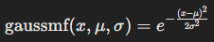

Figure.77. – Gaussmf Formula

# 8 - Code Appendix

## 8.1 - Exploratory Code

import numpy as np

import skfuzzy as fuzz

from skfuzzy import control as ctrl

# New Antecedent/Consequent objects hold universe variables and membership functions

symptom_severity = ctrl.Antecedent(np.arange(0, 11, 1), 'symptom_severity')

test_consistency = ctrl.Antecedent(np.arange(0, 11, 1), 'test_consistency')

history_relevance = ctrl.Antecedent(np.arange(0, 11, 1), 'history_relevance')

diagnosis_likelihood = ctrl.Consequent(np.arange(0, 11, 1), 'diagnosis_likelihood')

# Auto-membership function population is possible with .automf(3, 5, or 7)

symptom_severity.automf(3, names=['low', 'moderate', 'high'])

test_consistency.automf(3, names=['inconsistent', 'moderately consistent', 'consistent'])

history_relevance.automf(3, names=['irrelevant', 'somewhat relevant', 'highly relevant'])

# Custom membership functions can be built interactively with a familiar, Pythonic API

diagnosis_likelihood['unlikely'] = fuzz.trimf(diagnosis_likelihood.universe, [0, 0, 3])

diagnosis_likelihood['possible'] = fuzz.trimf(diagnosis_likelihood.universe, [2, 5, 8])

diagnosis_likelihood['probable'] = fuzz.trimf(diagnosis_likelihood.universe, [7, 9, 10])

diagnosis_likelihood['highly probable'] = fuzz.trimf(diagnosis_likelihood.universe, [8, 10, 10])

# Rules

rule1 = ctrl.Rule(symptom_severity['high'] & test_consistency['consistent'] & history_relevance['highly relevant'], diagnosis_likelihood['highly probable'])

rule2 = ctrl.Rule(symptom_severity['low'] | test_consistency['inconsistent'], diagnosis_likelihood['unlikely'])

# Control System Creation and Simulation

diagnosis_ctrl = ctrl.ControlSystem([rule1, rule2])

diagnosis = ctrl.ControlSystemSimulation(diagnosis_ctrl)

# Passing inputs to the ControlSystem using Antecedent labels with Pythonic API

diagnosis.input['symptom_severity'] = 6.5

diagnosis.input['test_consistency'] = 6.5

diagnosis.input['history_relevance'] = 6.5

# Crunch the numbers

diagnosis.compute()

print(diagnosis.output['diagnosis_likelihood'])

diagnosis_likelihood.view(sim=diagnosis)

## 8.2 - Data Generation Code

import numpy as np

import pandas as pd

# Set the random seed for reproducibility

np.random.seed(0)

# Define the number of pseudo data points

num_data_points = 100

# Generate pseudo patient data for the three inputs

# Assume that these inputs are normally distributed around a mean value, which is a common assumption for pseudo data generation.

# Symptom Severity ranges from 0 to 10, with most patients having moderate severity

symptom_severity = np.random.normal(loc=5, scale=2, size=num_data_points)

symptom_severity = np.clip(symptom_severity, 0, 10) # Ensure values are within bounds

# Test Result Consistency also ranges from 0 to 10, with most results being moderately consistent

test_consistency = np.random.normal(loc=5, scale=2, size=num_data_points)

test_consistency = np.clip(test_consistency, 0, 10) # Ensure values are within bounds

# Patient History Relevance ranges from 0 to 10, with a spread of relevancies

history_relevance = np.random.normal(loc=5, scale=2, size=num_data_points)

history_relevance = np.clip(history_relevance, 0, 10) # Ensure values are within bounds

# Create a DataFrame to hold the pseudo patient data

pseudo_patient_data = pd.DataFrame({

'Symptom Severity': symptom_severity,

'Test Result Consistency': test_consistency,

'Patient History Relevance': history_relevance

})

pseudo_patient_data.head()

# Print the entire DataFrame to the console

#with pd.option_context('display.max_rows', None, 'display.max_columns', None):

#print(pseudo_patient_data)

file_path = '/content/drive/MyDrive/Colab Notebooks/data/pseudo_patient_data.csv' # Path in Google Drive where you want to save the file

pseudo_patient_data.to_csv(file_path, index=False)

## 8.3 - Preliminary Data Generation & Testing Code

Here's the reasoning behind every decision in the data generation process:

##### Importing Libraries:

* numpy is used for numerical computing in Python, and here it aids in generating random data.
* pandas is a data manipulation library that provides an easy-to-use data structure (DataFrame) for storing and working with structured data.

##### Setting the Random Seed:

* np.random.seed(0) sets the seed for the random number generator, which ensures that the results are reproducible. This is essential in a scientific setting where experiments need to yield the same results across different runs for verification and validation purposes.

##### Defining the Number of Data Points:

* num_data_points = 100 specifies that the synthetic dataset will contain 100 entries. The number is sufficiently large to ensure variability but manageable for preliminary analysis and development.

##### Generating Pseudo Patient Data:

* The assumption that data is normally distributed around a mean value is a standard statistical approach for generating pseudo data, reflecting common clinical measurement distributions.

##### Symptom Severity:

* It ranges from 0 to 10, with a mean (loc) of 5 and a standard deviation (scale) of 2. This implies that most patients have moderate symptom severity, with the range and distribution mirroring realistic clinical assessments.

##### Test Result Consistency:

* Similar to symptom severity, test results range from 0 to 10, suggesting that most test results are expected to be moderately consistent. This reflects the variability that may be encountered in real test outcomes.

##### Patient History Relevance:

* This also spans a range from 0 to 10. The history's relevance to the current medical condition can vary, hence the same distribution as the other variables is used to capture a diversity of patient histories.

##### Clipping Values:

* np.clip() ensures that the generated values do not fall outside the realistic range of 0 to 10. This step is crucial because it enforces clinical validity in the pseudo dataset.

##### Creating a DataFrame:

* A DataFrame is constructed using pandas to organise the data into a structured format that is both easy to manipulate and ready for analysis.

##### Outputting the Data:

* pseudo_patient_data.head() is used to preview the first few rows of the DataFrame to verify the structure and content of the data.

##### Saving to CSV:

* The file path indicates a specific location in Google Drive where the CSV file will be stored. pseudo_patient_data.to_csv(file_path, index=False) writes the DataFrame to a CSV file without the index column, making the data ready for use outside of the Python environment.

Each decision in this data generation journey is made to ensure the synthetic dataset closely approximates the characteristics of actual patient data while maintaining the ability to control, reproduce, and ethically use the data for system development and testing purposes.

import numpy as np

import pandas as pd

from scipy.stats import shapiro

# Generate pseudo patient data again as the previous data was not saved due to an error.

np.random.seed(0) # Ensure reproducibility

num_data_points = 100

symptom_severity = np.clip(np.random.normal(5, 2, num_data_points), 0, 10)

test_consistency = np.clip(np.random.normal(5, 2, num_data_points), 0, 10)

history_relevance = np.clip(np.random.normal(5, 2, num_data_points), 0, 10)

pseudo_patient_data = pd.DataFrame({

'Symptom Severity': symptom_severity,

'Test Result Consistency': test_consistency,

'Patient History Relevance': history_relevance

})

# Descriptive Statistics

descriptive_stats = pseudo_patient_data.describe()

# Shapiro-Wilk Test

sw_test_results = {col: shapiro(pseudo_patient_data[col]) for col in pseudo_patient_data.columns}

# Null Values Check

null_values = pseudo_patient_data.isnull().sum()

# Outlier Detection

z_scores = np.abs((pseudo_patient_data - pseudo_patient_data.mean()) / pseudo_patient_data.std())

outliers_detected = (z_scores > 3).sum()

# Assembling the results

preliminary_tests_results = {

'Descriptive Statistics': descriptive_stats,

'Shapiro-Wilk Test': sw_test_results,

'Null Values': null_values,

'Outliers': outliers_detected

}

preliminary_tests_results

## 8.4 - First Three Runs MatLab Code

%% To suppress deprecation warnings

warning('off','fuzzy:general:warnDeprecation_Newfis')

warning('off','fuzzy:general:warnDeprecation_Addvar')

warning('off','fuzzy:general:warnDeprecation_Addmf')

warning('off','fuzzy:general:warnDeprecation_Evalfis')

%% Clear the Command Window to remove previous runs' clutter

clc

%% Data Setup

% File and Sheet Setup

dataFile = 'pseudo_patient_data.xlsx';

sheetName = 'Sheet1';

% Read Data Once

inputData = readmatrix(dataFile, 'Sheet', sheetName, 'Range', 'A2:C151');

disp('Size of inputData matrix:');

disp(size(inputData));

% Compute Mean Input for Use in Visualisations

meanInput = mean(inputData);

%% Creating a new Fuzzy Inference System (FIS) with specified parameters

% AND OR Impl Agg Defuzzification

%fis = newfis('MedicalDiagnosis','mamdani','min','max', 'min','max','centroid');

fis = newfis('MedicalDiagnosis','mamdani','min','max', 'min','max','mom');

%fis = newfis('MedicalDiagnosis','mamdani','min','max', 'min','max','lom');

%fis = newfis('MedicalDiagnosis','mamdani','min','max', 'min','max','som');

%fis = newfis('MedicalDiagnosis','mamdani','min','max', 'min','max','bisector');

% AND OR Impl Agg Defuzzification

%fis = newfis('MedicalDiagnosis','mamdani','prod','probor', 'prod','max','centroid');

%fis = newfis('MedicalDiagnosis','mamdani','prod','probor', 'prod','max','mom');

%fis = newfis('MedicalDiagnosis','mamdani','prod','probor', 'prod','max','lom');

%fis = newfis('MedicalDiagnosis','mamdani','prod','probor', 'prod','max','som');

%fis = newfis('MedicalDiagnosis','mamdani','prod','probor', 'prod','max','bisector');

%% Adding 'Symptom Severity' as an input variable

fis = addvar(fis, 'input', 'Symptom Severity', [0 10]);

% Defining membership functions for 'Symptom Severity'

fis = addmf(fis, 'input', 1, 'Low', 'trapmf', [0 0 2.5 5]);

fis = addmf(fis, 'input', 1, 'Medium', 'trimf', [1.5 5 8]);

fis = addmf(fis, 'input', 1, 'High', 'trapmf', [4 7.5 10 10]);

%% Adding 'Test Result Consistency' as an input variable

fis = addvar(fis, 'input', 'Test Result Consistency', [0 10]);

% Defining membership functions for 'Test Result Consistency'

fis = addmf(fis, 'input', 2, 'Inconsistent', 'trapmf', [0 0 2.5 5]);

fis = addmf(fis, 'input', 2, 'Moderately Consistent', 'trimf', [1.5 5 8]);

fis = addmf(fis, 'input', 2, 'Consistent', 'trapmf', [4 7.5 10 10]);

%% Adding 'Patient History Relevance' as an input variable

fis = addvar(fis, 'input', 'Patient History Relevance', [0 10]);

% Defining membership functions for 'Patient History Relevance'

fis = addmf(fis, 'input', 3, 'Irrelevant', 'trapmf', [0 0 2.5 5]);

fis = addmf(fis, 'input', 3, 'Somewhat Relevant', 'trimf', [1.5 5 8]);

fis = addmf(fis, 'input', 3, 'Highly Relevant', 'trapmf', [4 7.5 10 10]);

%% Adding 'Likelihood of Disease Diagnosis' as an output variable

fis = addvar(fis, 'output', 'Likelihood of Disease Diagnosis', [0 100]);

% Defining membership functions for the output

fis = addmf(fis, 'output', 1, 'Unlikely', 'trapmf', [0 0 25 50]);

fis = addmf(fis, 'output', 1, 'Possible', 'trimf', [30 50 70]);

fis = addmf(fis, 'output', 1, 'Probable', 'trimf', [50 70 90]);

fis = addmf(fis, 'output', 1, 'Highly Probable', 'trapmf', [70 85 100 100]);

% Full set of rules for the Medical Diagnosis FIS

rules = [

% Antecedent (Input 1, Input 2, Input 3), Consequent (Output), Weight, Operator (AND=1)

1 1 1 1 1 1; % If Symptom Severity is Low and Test Result Consistency is Inconsistent and Patient History Relevance is Irrelevant, then Likelihood of Disease Diagnosis is Unlikely

1 1 2 1 1 1; % If Symptom Severity is Low and Test Result Consistency is Inconsistent and Patient History Relevance is Somewhat Relevant, then Likelihood of Disease Diagnosis is Unlikely

1 1 3 2 1 1; % If Symptom Severity is Low and Test Result Consistency is Inconsistent and Patient History Relevance is Highly Relevant, then Likelihood of Disease Diagnosis is Possible

1 2 1 1 1 1; % If Symptom Severity is Low and Test Result Consistency is Moderately Consistent and Patient History Relevance is Irrelevant, then Likelihood of Disease Diagnosis is Unlikely

1 2 2 2 1 1; % If Symptom Severity is Low and Test Result Consistency is Moderately Consistent and Patient History Relevance is Somewhat Relevant, then Likelihood of Disease Diagnosis is Possible

1 2 3 2 1 1; % If Symptom Severity is Low and Test Result Consistency is Moderately Consistent and Patient History Relevance is Highly Relevant, then Likelihood of Disease Diagnosis is Possible

1 3 1 1 1 1; % If Symptom Severity is Low and Test Result Consistency is Consistent and Patient History Relevance is Irrelevant, then Likelihood of Disease Diagnosis is Unlikely

1 3 2 2 1 1; % If Symptom Severity is Low and Test Result Consistency is Consistent and Patient History Relevance is Somewhat Relevant, then Likelihood of Disease Diagnosis is Possible

1 3 3 3 1 1; % If Symptom Severity is Low and Test Result Consistency is Consistent and Patient History Relevance is Highly Relevant, then Likelihood of Disease Diagnosis is Probable

2 1 1 1 1 1; % If Symptom Severity is Moderate and Test Result Consistency is Inconsistent and Patient History Relevance is Irrelevant, then Likelihood of Disease Diagnosis is Unlikely

2 1 2 2 1 1; % If Symptom Severity is Moderate and Test Result Consistency is Inconsistent and Patient History Relevance is Somewhat Relevant, then Likelihood of Disease Diagnosis is Possible

2 1 3 2 1 1; % If Symptom Severity is Moderate and Test Result Consistency is Inconsistent and Patient History Relevance is Highly Relevant, then Likelihood of Disease Diagnosis is Possible

2 2 1 2 1 1; % If Symptom Severity is Moderate and Test Result Consistency is Moderately Consistent and Patient History Relevance is Irrelevant, then Likelihood of Disease Diagnosis is Possible

2 2 2 3 1 1; % If Symptom Severity is Moderate and Test Result Consistency is Moderately Consistent and Patient History Relevance is Somewhat Relevant, then Likelihood of Disease Diagnosis is Probable

2 2 3 3 1 1; % If Symptom Severity is Moderate and Test Result Consistency is Moderately Consistent and Patient History Relevance is Highly Relevant, then Likelihood of Disease Diagnosis is Probable

2 3 1 2 1 1; % If Symptom Severity is Moderate and Test Result Consistency is Consistent and Patient History Relevance is Irrelevant, then Likelihood of Disease Diagnosis is Possible

2 3 2 3 1 1; % If Symptom Severity is Moderate and Test Result Consistency is Consistent and Patient History Relevance is Somewhat Relevant, then Likelihood of Disease Diagnosis is Probable

2 3 3 4 1 1; % If Symptom Severity is Moderate and Test Result Consistency is Consistent and Patient History Relevance is Highly Relevant, then Likelihood of Disease Diagnosis is Highly Probable

3 1 1 2 1 1; % If Symptom Severity is High and Test Result Consistency is Inconsistent and Patient History Relevance is Irrelevant, then Likelihood of Disease Diagnosis is Possible

3 1 1 2 1 1; % If Symptom Severity is High and Test Result Consistency is Low and Patient History Relevance is Irrelevant, then Likelihood of Disease Diagnosis is Possible

3 1 2 1 1 1; % If Symptom Severity is High and Test Result Consistency is Low and Patient History Relevance is Somewhat Relevant, then Likelihood of Disease Diagnosis is Possible

3 1 3 1 1 1; % If Symptom Severity is High and Test Result Consistency is Low and Patient History Relevance is Highly Relevant, then Likelihood of Disease Diagnosis is Possible

3 2 1 3 1 1; % If Symptom Severity is High and Test Result Consistency is Moderate and Patient History Relevance is Irrelevant, then Likelihood of Disease Diagnosis is Probable

3 2 2 2 1 1; % If Symptom Severity is High and Test Result Consistency is Moderate and Patient History Relevance is Somewhat Relevant, then Likelihood of Disease Diagnosis is Probable

3 2 3 2 1 1; % If Symptom Severity is High and Test Result Consistency is Moderate and Patient History Relevance is Highly Relevant, then Likelihood of Disease Diagnosis is Probable

3 3 1 3 1 1; % If Symptom Severity is High and Test Result Consistency is High and Patient History Relevance is Irrelevant, then Likelihood of Disease Diagnosis is Highly Probable

3 3 2 3 1 1; % If Symptom Severity is High and Test Result Consistency is High and Patient History Relevance is Somewhat Relevant, then Likelihood of Disease Diagnosis is Highly Probable

3 3 3 3 1 1; % If Symptom Severity is High and Test Result Consistency is High and Patient History Relevance is Highly Relevant, then Likelihood of Disease Diagnosis is Highly Probable

];

% Add rules to the FIS

fis = addrule(fis, rules);

%% Evaluate FIS and Write Results

evaluateAndWriteFIS(fis, inputData, dataFile, sheetName, 'E2');

%% Visualising the system - for a detailed analysis and debugging

figure('Name','Input - Symptom Severity');

subplot(3,1,1), plotmf(fis, 'input', 1);

title('Symptom Severity Membership Functions');

subplot(3,1,2), plotmf(fis, 'input', 2);

title('Test Result Consistency Membership Functions');

subplot(3,1,3), plotmf(fis, 'input', 3);

title('Patient History Relevance Membership Functions');

figure('Name','Output - Likelihood of Disease Diagnosis');

subplot(1,1,1), plotmf(fis, 'output', 1);

title('Likelihood of Disease Diagnosis Membership Functions');

%% Surface Plot

figure;

[X, Y] = meshgrid(linspace(0, 10, 50), linspace(0, 10, 50));

Z = zeros(size(X));

for i = 1:numel(X)

Z(i) = evalfis([X(i), Y(i), meanInput(3)], fis);

end

surf(X, Y, Z);

xlabel('Symptom Severity'); ylabel('Test Result Consistency'); zlabel('FIS Output');

title('FIS Output Surface');

%% Rule Viewer Plot

figure;

ruleview(fis);

%% Sensitivity Analysis

symptomSeverityRange = linspace(0, 10, 100);

fisOutputForSensitivity = arrayfun(@(x) evalfis([x, meanInput(2:3)], fis), symptomSeverityRange);

figure;

plot(symptomSeverityRange, fisOutputForSensitivity);

title('Sensitivity Analysis for Symptom Severity');

xlabel('Symptom Severity'); ylabel('Likelihood of Disease Diagnosis');

%% Principal Component Analysis (PCA)

standardisedData = (inputData - mean(inputData)) ./ std(inputData);

[coeff, score, latent] = pca(standardisedData);

explainedVariance = cumsum(latent) / sum(latent) * 100;

figure; bar(explainedVariance);

title('PCA - Explained Variance');

xlabel('Principal Components'); ylabel('Percentage of Variance Explained');

figure; scatter(score(:,1), score(:,2));

title('PCA - Scatter Plot of the First Two Principal Components');

xlabel('Principal Component 1'); ylabel('Principal Component 2');

%% Function to Evaluate FIS and Write Results

function evaluateAndWriteFIS(fis, inputData, dataFile, sheetName, outputStartCell)

defuzzMethods = {'centroid', 'mom', 'lom', 'som', 'bisector'};

numDataPoints = size(inputData, 1);

results = zeros(numDataPoints, numel(defuzzMethods));

for i = 1:numel(defuzzMethods)

fis.DefuzzificationMethod = defuzzMethods{i};

results(:, i) = evalfis(inputData(:, 1:3), fis);

end

% Writing results to Excel

endRow = num2str(numDataPoints + 1);

outputRange = [outputStartCell ':' char('E' + numel(defuzzMethods) - 1) endRow];

writematrix(results, dataFile, 'Sheet', sheetName, 'Range', outputRange);

end

## 8.5 - Gaussian Membership Functions Code

%% To suppress deprecation warnings

warning('off','fuzzy:general:warnDeprecation_Newfis')

warning('off','fuzzy:general:warnDeprecation_Addvar')

warning('off','fuzzy:general:warnDeprecation_Addmf')

warning('off','fuzzy:general:warnDeprecation_Evalfis')

%% Clear the Command Window to remove previous runs' clutter

clc

%% Data Setup

% File and Sheet Setup

dataFile = 'pseudo_patient_data_1000dp.xlsx';

sheetName = 'Sheet1';

% Read Data Once

inputData = readmatrix(dataFile, 'Sheet', sheetName, 'Range', 'A2:C151');

disp('Size of inputData matrix:');

disp(size(inputData));

%% Define the standard deviation and mean for the Gaussian membership functions

% The standard deviation controls the width of the curve

% The mean determines the centre of the curve

% values for 'Very Unlikely' outcome

sigma_very_unlikely = 1;

mean_very_unlikely = 10;

% values for 'Unlikely' outcome

sigma_unlikely = 1;

mean_unlikely = 30;

% values for 'Possible' outcome

sigma_possible = 1;

mean_possible = 50;

% Example values for 'Probable' outcome

sigma_probable = 1;

mean_probable = 70;

% values for 'Very Likely' outcome

sigma_very_likely = 1;

mean_very_likely = 90;

% Compute Mean Input for Use in Visualisations

meanInput = mean(inputData);

%% Creating a new Fuzzy Inference System (FIS) with specified parameters

% AND OR Impl Agg Defuzzification

%fis = newfis('MedicalDiagnosis','mamdani','min','max', 'min','max','centroid');

fis = newfis('MedicalDiagnosis','mamdani','min','max', 'min','max','mom');

%fis = newfis('MedicalDiagnosis','mamdani','min','max', 'min','max','lom');

%fis = newfis('MedicalDiagnosis','mamdani','min','max', 'min','max','som');

%fis = newfis('MedicalDiagnosis','mamdani','min','max', 'min','max','bisector');

% AND OR Impl Agg Defuzzification

%fis = newfis('MedicalDiagnosis','mamdani','prod','probor', 'prod','max','centroid');

%fis = newfis('MedicalDiagnosis','mamdani','prod','probor', 'prod','max','mom');

%fis = newfis('MedicalDiagnosis','mamdani','prod','probor', 'prod','max','lom');

%fis = newfis('MedicalDiagnosis','mamdani','prod','probor', 'prod','max','som');

%fis = newfis('MedicalDiagnosis','mamdani','prod','probor', 'prod','max','bisector');

%% Adding 'Symptom Severity' as an input variable

fis = addvar(fis, 'input', 'Symptom Severity', [0 10]);

% Defining more nuanced membership functions for 'Symptom Severity'

fis = addmf(fis, 'input', 1, 'Very Low', 'gaussmf', [1 0]);

fis = addmf(fis, 'input', 1, 'Low', 'gaussmf', [1 2.5]);

fis = addmf(fis, 'input', 1, 'Medium Low', 'gaussmf', [1 5]);

fis = addmf(fis, 'input', 1, 'Medium High', 'gaussmf', [1 7.5]);

fis = addmf(fis, 'input', 1, 'High', 'gaussmf', [1 10]);

%% Adding 'Test Result Consistency' as an input variable

fis = addvar(fis, 'input', 'Test Result Consistency', [0 10]);

% Defining more nuanced membership functions for 'Test Result Consistency'

fis = addmf(fis, 'input', 2, 'Very Inconsistent', 'gaussmf', [1 0]);

fis = addmf(fis, 'input', 2, 'Inconsistent', 'gaussmf', [1 2.5]);

fis = addmf(fis, 'input', 2, 'Moderately Consistent', 'gaussmf', [1 5]);

fis = addmf(fis, 'input', 2, 'Consistent', 'gaussmf', [1 7.5]);

fis = addmf(fis, 'input', 2, 'Very Consistent', 'gaussmf', [1 10]);

%% Adding 'Patient History Relevance' as an input variable

fis = addvar(fis, 'input', 'Patient History Relevance', [0 10]);

% Defining more nuanced membership functions for 'Patient History Relevance'

fis = addmf(fis, 'input', 3, 'Very Irrelevant', 'gaussmf', [1 0]);

fis = addmf(fis, 'input', 3, 'Irrelevant', 'gaussmf', [1 2.5]);

fis = addmf(fis, 'input', 3, 'Somewhat Relevant', 'gaussmf', [1 5]);

fis = addmf(fis, 'input', 3, 'Relevant', 'gaussmf', [1 7.5]);

fis = addmf(fis, 'input', 3, 'Highly Relevant', 'gaussmf', [1 10]);

%% Define output variable with appropriate membership functions

fis = addvar(fis, 'output', 'Likelihood of Disease Diagnosis', [0 100]);

% Adding membership functions for 'Likelihood of Disease Diagnosis' output variable

fis = addmf(fis, 'output', 1, 'Very Unlikely', 'gaussmf', [sigma_very_unlikely mean_very_unlikely]);

fis = addmf(fis, 'output', 1, 'Unlikely', 'gaussmf', [sigma_unlikely mean_unlikely]);

fis = addmf(fis, 'output', 1, 'Possible', 'gaussmf', [sigma_possible mean_possible]);

fis = addmf(fis, 'output', 1, 'Probable', 'gaussmf', [sigma_probable mean_probable]);

fis = addmf(fis, 'output', 1, 'Very Likely', 'gaussmf', [sigma_very_likely mean_very_likely]);

%% Full set of rules for the Medical Diagnosis FIS

% Define a matrix to store all the rules

numLevels = 5; % Number of levels for each input and output variable

numInputs = 3; % Number of input variables

rules = zeros(numLevels^numInputs, numInputs+3); % Preallocate the rules matrix

% Generate all possible combinations of rules

ruleCounter = 1;

for i = 1:numLevels % Symptom Severity levels

for j = 1:numLevels % Test Result Consistency levels

for k = 1:numLevels % Patient History Relevance levels

% The consequent (output) can be decided based on a strategy.

% Here, we take a simple average of the input levels

consequent = round(mean([i, j, k]));

rules(ruleCounter, :) = [i j k consequent 1 1]; % Last two are weight and operator

ruleCounter = ruleCounter + 1;

end

end

end

% Add rules to FIS

fis = addrule(fis, rules);

%% Evaluate FIS and Write Results

evaluateAndWriteFIS(fis, inputData, dataFile, sheetName, 'E2');

%% Visualising the system - for a detailed analysis and debugging

figure('Name','Input - Symptom Severity');

subplot(3,1,1), plotmf(fis, 'input', 1);

title('Symptom Severity Membership Functions');

subplot(3,1,2), plotmf(fis, 'input', 2);

title('Test Result Consistency Membership Functions');

subplot(3,1,3), plotmf(fis, 'input', 3);

title('Patient History Relevance Membership Functions');

figure('Name','Output - Likelihood of Disease Diagnosis');

subplot(1,1,1), plotmf(fis, 'output', 1);

title('Likelihood of Disease Diagnosis Membership Functions');

%% Surface Plot

figure;

[X, Y] = meshgrid(linspace(0, 10, 50), linspace(0, 10, 50));

Z = zeros(size(X));

for i = 1:numel(X)

Z(i) = evalfis([X(i), Y(i), meanInput(3)], fis);

end

surf(X, Y, Z);

xlabel('Symptom Severity'); ylabel('Test Result Consistency'); zlabel('FIS Output');

title('FIS Output Surface');

%% Rule Viewer Plot

figure;

ruleview(fis);

%% Sensitivity Analysis

symptomSeverityRange = linspace(0, 10, 100);

fisOutputForSensitivity = arrayfun(@(x) evalfis([x, meanInput(2:3)], fis), symptomSeverityRange);

figure;

plot(symptomSeverityRange, fisOutputForSensitivity);

title('Sensitivity Analysis for Symptom Severity');

xlabel('Symptom Severity'); ylabel('Likelihood of Disease Diagnosis');

%% Principal Component Analysis (PCA)

standardisedData = (inputData - mean(inputData)) ./ std(inputData);

[coeff, score, latent] = pca(standardisedData);

explainedVariance = cumsum(latent) / sum(latent) * 100;

figure; bar(explainedVariance);

title('PCA - Explained Variance');

xlabel('Principal Components'); ylabel('Percentage of Variance Explained');

figure; scatter(score(:,1), score(:,2));

title('PCA - Scatter Plot of the First Two Principal Components');

xlabel('Principal Component 1'); ylabel('Principal Component 2');

%% Function to Evaluate FIS and Write Results

function evaluateAndWriteFIS(fis, inputData, dataFile, sheetName, outputStartCell)

defuzzMethods = {'centroid', 'mom', 'lom', 'som', 'bisector'};

numDataPoints = size(inputData, 1);

results = zeros(numDataPoints, numel(defuzzMethods));

for i = 1:numel(defuzzMethods)

fis.DefuzzificationMethod = defuzzMethods{i};

results(:, i) = evalfis(inputData(:, 1:3), fis);

end

% Writing results to Excel

endRow = num2str(numDataPoints + 1);

outputRange = [outputStartCell ':' char('E' + numel(defuzzMethods) - 1) endRow];

writematrix(results, dataFile, 'Sheet', sheetName, 'Range', outputRange);

end

## 8.6 - Different Code Variations

### 8.6.1 - Gaussian Membership Functions

%% Adding 'Symptom Severity' as an input variable

fis = addvar(fis, 'input', 'Symptom Severity', [0 10]);

% Defining membership functions for 'Symptom Severity'

fis = addmf(fis, 'input', 1, 'Very Low', 'gaussmf', [1.5 0]); % Increased sigma for more overlap

fis = addmf(fis, 'input', 1, 'Low', 'gaussmf', [1.5 2.5]);

fis = addmf(fis, 'input', 1, 'Medium', 'gaussmf', [1.5 5]);

fis = addmf(fis, 'input', 1, 'High', 'gaussmf', [1.5 7.5]);

fis = addmf(fis, 'input', 1, 'Very High', 'gaussmf', [1.5 10]);

%% Adding 'Test Result Consistency' as an input variable

fis = addvar(fis, 'input', 'Test Result Consistency', [0 10]);

% Defining membership functions for 'Test Result Consistency'

fis = addmf(fis, 'input', 2, 'Very Inconsistent', 'gaussmf', [1.5 0]);

fis = addmf(fis, 'input', 2, 'Inconsistent', 'gaussmf', [1.5 2.5]);

fis = addmf(fis, 'input', 2, 'Moderately Consistent', 'gaussmf', [1.5 5]);

fis = addmf(fis, 'input', 2, 'Consistent', 'gaussmf', [1.5 7.5]);

fis = addmf(fis, 'input', 2, 'Very Consistent', 'gaussmf', [1.5 10]);

%% Adding 'Patient History Relevance' as an input variable

fis = addvar(fis, 'input', 'Patient History Relevance', [0 10]);

% Defining membership functions for 'Patient History Relevance'

fis = addmf(fis, 'input', 3, 'Very Irrelevant', 'gaussmf', [1.5 0]);

fis = addmf(fis, 'input', 3, 'Irrelevant', 'gaussmf', [1.5 2.5]);

fis = addmf(fis, 'input', 3, 'Somewhat Relevant', 'gaussmf', [1.5 5]);

fis = addmf(fis, 'input', 3, 'Relevant', 'gaussmf', [1.5 7.5]);

fis = addmf(fis, 'input', 3, 'Highly Relevant', 'gaussmf', [1.5 10]);

### 8.6.2 - Trimf Membership Functions

% Adding 'Symptom Severity' as an input variable

fis = addvar(fis, 'input', 'Symptom Severity', [0 10]);

% Defining triangular membership functions for 'Symptom Severity'

fis = addmf(fis, 'input', 1, 'Very Low', 'trimf', [0 0 2.5]);

fis = addmf(fis, 'input', 1, 'Low', 'trimf', [0 2.5 5]);

fis = addmf(fis, 'input', 1, 'Medium', 'trimf', [2.5 5 7.5]);

fis = addmf(fis, 'input', 1, 'High', 'trimf', [5 7.5 10]);

fis = addmf(fis, 'input', 1, 'Very High', 'trimf', [7.5 10 10]);

% Adding 'Test Result Consistency' as an input variable

fis = addvar(fis, 'input', 'Test Result Consistency', [0 10]);

% Defining triangular membership functions for 'Test Result Consistency'

fis = addmf(fis, 'input', 2, 'Very Inconsistent', 'trimf', [0 0 2.5]);

fis = addmf(fis, 'input', 2, 'Inconsistent', 'trimf', [0 2.5 5]);

fis = addmf(fis, 'input', 2, 'Moderately Consistent', 'trimf', [2.5 5 7.5]);

fis = addmf(fis, 'input', 2, 'Consistent', 'trimf', [5 7.5 10]);

fis = addmf(fis, 'input', 2, 'Very Consistent', 'trimf', [7.5 10 10]);

% Adding 'Patient History Relevance' as an input variable

fis = addvar(fis, 'input', 'Patient History Relevance', [0 10]);

% Defining triangular membership functions for 'Patient History Relevance'

fis = addmf(fis, 'input', 3, 'Very Irrelevant', 'trimf', [0 0 2.5]);

fis = addmf(fis, 'input', 3, 'Irrelevant', 'trimf', [0 2.5 5]);

fis = addmf(fis, 'input', 3, 'Somewhat Relevant', 'trimf', [2.5 5 7.5]);

fis = addmf(fis, 'input', 3, 'Relevant', 'trimf', [5 7.5 10]);

fis = addmf(fis, 'input', 3, 'Highly Relevant', 'trimf', [7.5 10 10]);

### 8.6.3 - Trapmf Membership functions

% Adding 'Symptom Severity' as an input variable

fis = addvar(fis, 'input', 'Symptom Severity', [0 10]);

% Defining trapezoidal membership functions for 'Symptom Severity'

fis = addmf(fis, 'input', 1, 'Very Low', 'trapmf', [0 0 1 3]);

fis = addmf(fis, 'input', 1, 'Low', 'trapmf', [1 3 4 6]);

fis = addmf(fis, 'input', 1, 'Medium', 'trapmf', [4 6 7 9]);

fis = addmf(fis, 'input', 1, 'High', 'trapmf', [7 9 10 10]);

fis = addmf(fis, 'input', 1, 'Very High', 'trapmf', [8 10 10 10]);

% Adding 'Test Result Consistency' as an input variable

fis = addvar(fis, 'input', 'Test Result Consistency', [0 10]);

% Defining trapezoidal membership functions for 'Test Result Consistency'

fis = addmf(fis, 'input', 2, 'Very Inconsistent', 'trapmf', [0 0 1 3]);

fis = addmf(fis, 'input', 2, 'Inconsistent', 'trapmf', [1 3 4 6]);

fis = addmf(fis, 'input', 2, 'Moderately Consistent', 'trapmf', [4 6 7 9]);

fis = addmf(fis, 'input', 2, 'Consistent', 'trapmf', [7 9 10 10]);

fis = addmf(fis, 'input', 2, 'Very Consistent', 'trapmf', [8 10 10 10]);

% Adding 'Patient History Relevance' as an input variable

fis = addvar(fis, 'input', 'Patient History Relevance', [0 10]);

% Defining trapezoidal membership functions for 'Patient History Relevance'

fis = addmf(fis, 'input', 3, 'Very Irrelevant', 'trapmf', [0 0 1 3]);

fis = addmf(fis, 'input', 3, 'Irrelevant', 'trapmf', [1 3 4 6]);

fis = addmf(fis, 'input', 3, 'Somewhat Relevant', 'trapmf', [4 6 7 9]);

fis = addmf(fis, 'input', 3, 'Relevant', 'trapmf', [7 9 10 10]);

fis = addmf(fis, 'input', 3, 'Highly Relevant', 'trapmf', [8 10 10 10]);